
CSA15 – CLOUD COMPUTING AND BIG DATA ANALYTICS

ASSIGNMENT 1 – CO1
Design, Analyse and Validate a Cloud-Based Solution for Migrating a Legacy University Management System
CO1: Apply cloud computing technologies including hardware–software evolution, virtualization, web services, and service models to develop cloud-based solutions.

Field | Details | Field | Details
Student Name | i.jaswanth | Register Number | 192525345
Department / Section | AI & ML | Academic Year / Semester
Faculty Name |  | Nature of Assignment | Individual
Duration | 1 Week | Total Marks | 50
Submission Date |  | Evaluation Date

MARK SHEET (Rubric-based evaluation)
Task | Title | Max | Awarded | Evidence / evaluation focus
1 | Introduce Cloud Computing | 3 |  | Definition; characteristics; deployment models; scenario mapping
2 | Trace Evolution and Hardware Evolution | 3 |  | Timeline; hardware evolution; relevance to university
3 | Analyse Internet Software Evolution | 3 |  | Web/software evolution; SOA; APIs; scenario relevance
4 | Apply Server Virtualization | 5 |  | Hypervisor types; VM/container comparison; consolidation; limitations
5 | Apply Web Services | 4 |  | SOA and SOAP/REST; three university APIs; request/response examples
6 | Analyse IaaS, PaaS and SaaS | 5 |  | Responsibility layers; five-application mapping; comparison; providers
7 | Examine XaaS | 3 |  | Four or more variants; two justified choices; provider risks
8 | Design Cloud Solution Architecture | 5 |  | Labelled diagram; deployment/service models; scaling; security; DR
9 | Hands-on Implementation and Documentation | 4 |  | Running VM/container; PaaS/SaaS; tests; actual screenshots
10 | Evaluate and Recommend Final Solution | 7 |  | Three-way comparison; 3-year costs; risks; phased roadmap
11 | Day-4 Design Challenge | 8 |  | Impact; evaluation; adaptation; evidence-based defence
 | TOTAL | 50 |  | Percentage :

EVIDENCE VERIFICATION CHECKLIST

Tasks | Evidence expected | Status (✓ / P / ✗) | Evaluator note
1–3 | Conceptual explanations, comparisons and relevant illustrations | ✓ | Explanations and relevant scenario mapping documented
4 | Virtualization calculations with stated assumptions and peak-load caution | ✓ | Calculations present; practical capacity validation recommended
5–7 | API examples, service responsibility table and justified XaaS choices | ✓ | Required conceptual evidence documented
8 | Labelled architecture diagram, caption below figure and component justification | ✓ | Architecture documented; sizing assumptions need testing
9 | Actual code, environment details, execution logs, API outputs and screenshots | P | Procedures provided; actual execution evidence not established
10 | Cost assumptions, 3-year totals, risk controls and migration roadmap | ✓ | Estimates and rationale documented
11 | Day-4 changes, 10× load strategy, 99.9% target and 40-college isolation | ✓ | Design analysis documented; practical validation pending

IMPLEMENTATION EVIDENCE CHAIN

Evidence item | Status | Observation
Source code | ✓ | Flask REST API and Dockerfile provided in the proposed implementation
Virtualization | P | Docker container configuration documented; running-container evidence required
PaaS or SaaS | P | Managed web-service deployment procedure described; live deployment not verified
Functional test | P | Expected HTTP 200 response and JSON output documented; actual output required
Failure case | P | HTTP 404 test case documented; actual execution record required
Screenshots | P | Screenshot requirements identified; authentic screenshots need verification
Reproducibility | ✓ | Build commands, run commands, endpoints and expected results specified

OVERALL REMARKS

_______________  Student Signature | _______________  Faculty Signature | _______________  Program Director
MANDATORY SUBMISSION EVIDENCE CHECK
✓ = Present in documented answer; P = Partly present; ✗ = Missing / not satisfied
Task | Evidence expected | Status | Evaluator note
1 | Cloud definition, characteristics, deployment models and scenario mapping | ✓ | All conceptual requirements covered
2 | Evolution timeline, hardware development and university relevance | ✓ | Well explained with relevant examples
3 | Internet software evolution, SOA and APIs | ✓ | Clear explanation and scenario relevance
4 | Hypervisors, VM/container comparison and consolidation calculations | ✓ | Calculations included; peak-load limitations discussed
5 | SOAP/REST comparison and three university APIs | ✓ | API methods and request/response examples documented
6 | IaaS/PaaS/SaaS responsibility layers and application mapping | ✓ | All five applications categorized with justification
7 | XaaS variants and two justified selections | ✓ | Six variants explained; DBaaS and DRaaS recommended
8 | Labelled architecture, scaling, security and disaster recovery | ✓ | Design and component justifications documented
9 | Working container, PaaS/SaaS deployment, actual tests and screenshots | P | Code and procedures provided; actual execution evidence requires verification
10 | Three-year cost comparison, risks and migration roadmap | ✓ | Cost assumptions, calculations and recommendations included
11 | Impact analysis, 10× load, 99.9% availability and tenant isolation | ✓ | Changed requirements evaluated; load-test evidence recommended

IMPLEMENTATION EVIDENCE CHAIN
Evidence item | Status | Observation
Source code | ✓ | Python Flask REST API and Dockerfile documented
Virtualization | P | Docker build and run procedures provided; execution screenshot required
PaaS or SaaS | P | Cloud deployment steps described; actual deployment confirmation required
Functional test | P | HTTP 200 and expected JSON response documented; actual test output required
Failure case | P | HTTP 404 test case included; execution evidence required
Screenshots | P | Required screenshots identified but authenticity and completeness not verified
Reproducibility | ✓ | Installation, configuration, commands and testing steps documented
Interpretation | ✓ | Technical outcomes and implementation limitations explained
Code and report consistency | ✓ | Proposed API, Docker configuration and testing procedure are aligned

SUBMISSION CHECKLIST (Not Separately Marked)
Requirement | Status
All 11 tasks answered | ☒ Yes ☐ Partly ☐ No
Cloud concepts and comparisons explained | ☒ Yes ☐ Partly ☐ No
Virtualization calculations included | ☒ Yes ☐ Partly ☐ No
API examples and service models explained | ☒ Yes ☐ Partly ☐ No
Cloud architecture diagram included | ☒ Yes ☐ Partly ☐ No
Implementation and testing evidence provided | ☐ Yes ☒ Partly ☐ No
Three-year cost analysis and roadmap included | ☒ Yes ☐ Partly ☐ No
Day-4 design challenge completed | ☒ Yes ☐ Partly ☐ No
Figures and screenshots included | ☐ Yes ☒ Partly ☐ No
Table and figure numbering correct | ☐ Yes ☒ Partly ☐ No
Viva recommended | ☒ Yes ☐ No

CSA15 – Cloud Computing and Big Data Analytics
ASSIGNMENT 1
CO1: Apply cloud computing technologies including hardware–software evolution, virtualization, web services, and service models to develop cloud-based solutions.

Assignment Title: Design, Analyse and Validate a Cloud-Based Solution for Migrating a Legacy University Management System (Total Marks – 50)
Duration: 1 week
Scenario – Smart Campus Cloud Migration
A multi-campus university currently runs its Student Information System, Learning Management System, Library System, Exam Portal and Email on ageing physical servers in a single on-premise data centre. Each application has its own dedicated server, which stays idle for most of the year but fails to cope during admissions, result publication and online-exam weeks.
The university's current environment is:
- 12 physical servers, average CPU utilisation of about 15%, with peaks above 95% during admissions and exams
- Approximately 25,000 students and 2,000 staff across 4 campuses
- Applications built as large monolithic programs, with no public interfaces for mobile apps or partner colleges
- High capital expenditure, slow procurement (6–8 weeks per server) and no disaster recovery site
As a cloud consultant, you must study how computing evolved to the cloud model, and then design a cloud-based solution that uses virtualization, web services and an appropriate mix of service models (IaaS, PaaS, SaaS and XaaS) for the university. All recommendations must be justified in terms of cost, scalability, availability and manageability.
Design Challenge:
On Day 4, the university announces that it will launch a mobile app and open student-record and fee-payment services to 40 affiliated colleges. Expected load is 10 times the current peak, with a requirement of 99.9% availability and a limited operating budget. Re-evaluate your original design and decide whether it should be retained, modified or redesigned.
TASK 1 – Introduce Cloud Computing and Map It to the Scenario (3 Marks)
Design and Propose cloud computing model for the context of the university's problems.
- Definition of cloud computing and the five essential characteristics (on-demand self-service, broad network access, resource pooling, rapid elasticity, measured service)
- Deployment models (public, private, hybrid, community) and which one suits the university
- Three problems of the current on-premise setup and how each cloud characteristic addresses them
- Benefits and limitations of cloud adoption for the university
Evidence Expected
A clear explanation of cloud characteristics and deployment models, mapped to the university's actual problems.
TASK 2 – Trace the Evolution and Hardware Evolution (3 Marks)
Trace how computing infrastructure evolved to make cloud computing possible.
- A timeline from mainframes, minicomputers and PCs, to client–server, clusters, grid computing, utility computing and cloud
- Hardware evolution: multi-core processors, commodity servers, high-capacity storage, high-speed networking and data centres
- How each stage solved a limitation of the previous one
- Which stage the university's current system corresponds to, with reasons
Evidence Expected
A labelled timeline or diagram, with a justified explanation of how hardware advances enabled the cloud.
TASK 3 – Analyse Internet Software Evolution (3 Marks)
Explain how internet software evolved and why it supports cloud services.
- Evolution from static web pages to dynamic web, Web 2.0, SOA, mashups and cloud-hosted applications
- Role of browsers, HTTP, AJAX and APIs in delivering software over the internet
- Comparison between desktop software, client–server software and web-delivered software
- How this evolution affects the design of the university's applications
Evidence Expected
A comparative explanation of software evolution stages, linked to the university's application design.
TASK 4 – Apply Server Virtualization (5 Marks)
Apply server virtualization to consolidate the university's 12 physical servers.
- Explain how a hypervisor works, and distinguish Type-1 and Type-2 hypervisors, with examples
- Compare full virtualization, para-virtualization, OS-level virtualization (containers) and hardware-assisted virtualization
- Propose which applications should run as virtual machines and which as containers, with reasons
- Calculate the consolidation: with an average utilisation of 15% per server and a target host utilisation of 70%, estimate how many physical hosts are needed (show your assumptions and working)
- Discuss live migration, snapshots and resource over-commitment as benefits, and the risks of virtualization (noisy neighbour, hypervisor failure, security isolation)
Show your calculation. A final number without working will not receive full credit.
Evidence Expected
A justified virtualization plan with a worked consolidation calculation and discussion of benefits and risks.
TASK 5 – Apply Web Services (4 Marks)
Analyse web services to expose the university's functions to other systems.
- Overview of web services and their role in cloud and SOA
- Compare SOAP, WSDL, UDDI and RESTful services (HTTP methods, JSON/XML)
- Identify at least three university functions to expose as web services (for example, result lookup, fee payment, library search) and define the endpoint, method and sample request/response for each
- Justify whether SOAP or REST is more suitable for each function
Evidence Expected
A defined set of web services with sample request/response formats and a justified choice of SOAP or REST
TASK 6 – Analyse the Service Models: IaaS, PaaS and SaaS (5 Marks)
Analyse which service model fits each university application.
- Define IaaS, PaaS and SaaS, and show who manages which layer (hardware to application) in each model
- Categorise the five university applications (SIS, LMS, Library, Exam Portal, Email) into IaaS, PaaS or SaaS, with reasons
- Compare the models on control, cost, scalability, maintenance effort and vendor lock-in
- Give one real provider example for each model
Present your categorisation in a table, but explain the reasoning behind each decision. A table alone is not sufficient.
Evidence Expected
A reasoned mapping of applications to service models, supported by a layer-wise responsibility comparison.
TASK 7 – Examine XaaS (3 Marks)
Examine the broader XaaS (Anything-as-a-Service) concept for the university.
- Explain XaaS and describe at least four variants (for example DaaS, BaaS/MBaaS, FaaS, DBaaS, Security-as-a-Service, Disaster-Recovery-as-a-Service)
- Select two XaaS offerings that would benefit the university, and justify them
- Discuss the risks of over-reliance on multiple 'as-a-Service' providers
Evidence Expected
An analysis of XaaS variants, with justified selection of two offerings for the university.
TASK 8 – Design the Cloud Solution Architecture (5 Marks)
Bloom's Level: Level 6 – Create | Action verbs: Design, Construct, Propose
Create a complete cloud architecture for the university by combining virtualization, web services and service models.
- An architecture diagram showing users, load balancer, web/application tier, database tier, storage, API layer and DR region
- The deployment model and the service model chosen for each component
- How elasticity (auto-scaling) will handle admissions and exam peaks
- Basic security and availability measures (access control, encryption, backup, multi-zone deployment)
Evidence Expected
A labelled architecture diagram with written justification for each component and design decision.
TASK 9 – Hands-on Implementation and Documentation (4 Marks)
Implement a small proof-of-concept of your design using a free-tier cloud account or a local virtualization tool.
- Create a virtual machine or container (using AWS/Azure/GCP free tier, VirtualBox, or Docker) and host a simple web page or REST API for one university function
- Deploy a SaaS or PaaS component (for example a cloud-hosted database, a serverless function or a static site)
- Test the web service with a client (browser, Postman or curl) and record the output
- Provide screenshots, configuration steps and any issues faced
Evidence Expected
Annotated screenshots and clear, reproducible steps showing that the proof-of-concept works.
TASK 10 – Evaluate and Recommend the Final Solution (7 Marks)
Evaluate your design and recommend the final cloud solution for the university.
- Compare on-premise, IaaS-based and PaaS/SaaS-based options on cost (CapEx vs OpEx), scalability, availability, security and effort
- Estimate a simple 3-year cost comparison using stated assumptions
- Identify the main risks (vendor lock-in, data privacy, downtime, skills gap) and give mitigation steps
- Provide your final recommendation and a short migration roadmap (which application moves first, and why)
Your recommendation must be supported by the analysis in the previous tasks. Choosing a popular cloud provider without justification is not sufficient.
Evidence Expected
A technically justified recommendation, supported by a cost comparison, risk analysis and migration roadmap.
DAY-4 DESIGN CHALLENGE
TASK 11 – Re-evaluate and Adapt the Design (8 Marks)
Changed Requirement
The university will now launch a mobile app and open student-record and fee-payment services to 40 affiliated colleges. Expected load is 10 times the current peak, availability must be 99.9%, and the operating budget is limited.
Re-evaluate your original design in response to these changed conditions. You may:
RETAIN → MODIFY → or REDESIGN
your original solution.
Impact Analysis – 2 Marks
Discuss:
- What has changed from the original problem
- Which original assumptions (load, users, availability, cost) are affected
- Why the web services and APIs now become critical
- How multi-tenant access by 40 colleges affects security and isolation
Evidence Expected: A clear analysis of how the changed requirements affect the original cloud design.
Evaluation of the Original Design – 2 Marks
Discuss:
- Whether the chosen service models and virtualization plan can handle a 10x load
- Whether auto-scaling and the single-region deployment are sufficient for 99.9% availability (about 8.76 hours of downtime allowed per year)
- Whether cost remains acceptable under the new load
- Whether another service model or XaaS offering would give better overall results
Evidence Expected: A technically supported evaluation of the original design under the new conditions.
Adaptation or Redesign – 2 Marks
Discuss:
- Decide whether to retain, modify or redesign the solution
- Describe the revised architecture (for example API gateway, container orchestration, serverless components, multi-zone deployment or a hybrid model)
- Explain what changed in the service model mix and in the virtualization approach
- If you retain the original design, give sufficient technical justification for why no change is required
Evidence Expected: An appropriate design response to the changed requirement, with clear technical reasoning.
Evidence-Based Defence – 2 Marks
Discuss:
- Capacity and availability calculations
- Cost comparison between the original and the revised design
- Security and multi-tenancy considerations
- Trade-offs such as vendor lock-in, complexity and migration effort
Evidence Expected: A well-supported final decision that follows logically from the analysis.
MARK DISTRIBUTION
Task | Title | Bloom's Level | Marks
Task 1 | Cloud Computing – Introduction & Characteristics | L2 – Understand | 3
Task 2 | Evolution & Hardware Evolution | L2 – Understand | 3
Task 3 | Internet Software Evolution | L2 – Understand | 3
Task 4 | Server Virtualization | L3 – Apply | 5
Task 5 | Web Services | L3 – Apply | 4
Task 6 | Service Models: IaaS, PaaS, SaaS | L4 – Analyze | 5
Task 7 | XaaS | L4 – Analyze | 3
Task 8 | Design the Cloud Solution Architecture | L6 – Create | 5
Task 9 | Hands-on Implementation & Documentation | L3 – Apply | 4
Task 10 | Evaluate & Recommend the Final Solution | L5 – Evaluate | 7
 | Subtotal

Task 11 | Day-4 Design Challenge | L4 / L5 / L6 | 8
 | TOTAL |  | 50
TASK 1 – Introduction to Cloud Computing and Mapping It to the University Scenario
1. Definition of Cloud Computing
Cloud computing is a technology that provides computing resources such as servers, storage, databases, networking, and software through the internet. Instead of maintaining physical servers and IT infrastructure on campus, a university can use cloud services to store data, manage applications, and provide services to students, faculty, and administrators.
Example: A university can use cloud computing to manage student records, online examinations, attendance, learning management systems (LMS), and fee payment portals without depending entirely on physical campus servers.
2. Five Essential Characteristics of Cloud Computing
According to the NIST cloud computing model, cloud computing has five essential characteristics.
Characteristic | Explanation | Application in University
1. On-Demand Self-Service | Users can access computing resources whenever required without contacting the service provider. | Students and faculty can access cloud applications and storage whenever needed.
2. Broad Network Access | Cloud services are accessible through the internet using different devices. | Students can access study materials, attendance, and examination portals using laptops and smartphones.
3. Resource Pooling | Computing resources are shared among multiple users based on their requirements. | The university can share cloud storage and computing resources among different departments.
4. Rapid Elasticity | Resources can be increased or decreased according to demand. | During online examinations or admission periods, the university can increase server capacity and reduce it afterward.
5. Measured Service | Cloud resource usage is monitored and measured based on consumption. | The university pays according to the storage, processing power, and services it actually uses.
3. Cloud Deployment Models
Cloud computing provides four major deployment models.
Deployment Model | Description | University Suitability
Public Cloud | Cloud infrastructure is provided by third-party providers and shared among multiple customers. | Suitable for hosting websites, learning platforms, and general applications.
Private Cloud | Cloud infrastructure is dedicated to a single organization. | Suitable for confidential student records, examination data, and financial information.
Hybrid Cloud | Combines public and private cloud environments. | Highly suitable because it provides flexibility, security, and cost efficiency.
Community Cloud | Cloud infrastructure is shared by organizations with similar requirements. | Suitable for multiple universities sharing educational and research resources.
Proposed Cloud Model for the University
Recommended: Hybrid Cloud
The Hybrid Cloud Model is the most suitable solution for the university because it combines the advantages of public and private clouds.
- Private Cloud: Stores sensitive information such as student personal records, examination results, employee details, and financial data.
- Public Cloud: Hosts university websites, online learning platforms, digital libraries, and general applications.
- Integration: Both environments are connected securely, allowing authorized users to access required services.

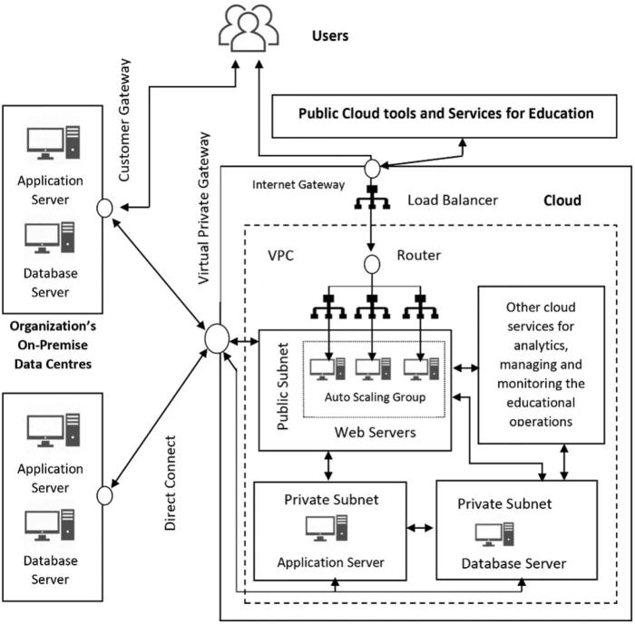
4. Three Problems in the Current On-Premise Setup and Cloud-Based Solutions
The university's existing on-premise infrastructure may face the following problems:
Current Problem | Cloud Characteristic | Cloud-Based Solution
1. Limited Server Capacity: Physical servers cannot handle a large number of students accessing the system simultaneously. | Rapid Elasticity | Cloud resources can automatically scale up during admission, examinations, and result publication.
2. Limited Accessibility: Students and faculty may not be able to access university services outside the campus. | Broad Network Access | Cloud applications can be accessed from anywhere through the internet using laptops and smartphones.
3. High Maintenance Cost: Maintaining physical servers, storage devices, electricity, and IT infrastructure requires significant investment. | Resource Pooling and Measured Service | Shared cloud resources reduce infrastructure costs, and the university pays according to actual usage.
5. Benefits of Cloud Adoption for the University
- Cost Reduction: Reduces investment in physical servers, hardware, and maintenance.
- Scalability: Supports increasing numbers of students and faculty without purchasing additional physical servers.
- Accessibility: Provides access to educational resources and university services from anywhere.
- Data Backup: Supports automatic backups and disaster recovery.
- Improved Collaboration: Allows students and faculty to share files, documents, and learning materials.
- Better Performance: Provides flexible computing resources during peak academic activities.
6. Limitations of Cloud Adoption
- Internet Dependency: Cloud services require a stable internet connection.
- Security Risks: Sensitive student and university information must be protected against unauthorized access.
- Data Privacy: The university must ensure that student records are stored and processed securely.
- Service Downtime: Cloud provider failures may temporarily interrupt university services.
- Vendor Lock-in: Moving applications and data from one cloud provider to another may be difficult.

7. Conclusion
Cloud computing provides an efficient and flexible solution to the university's existing infrastructure problems. By adopting a Hybrid Cloud Deployment Model, the university can maintain sensitive information in a private cloud while using public cloud services for online learning, websites, and other applications. The five essential characteristics of cloud computing help improve accessibility, scalability, resource utilization, and cost efficiency. Therefore, hybrid cloud adoption can support the university's digital transformation and improve its educational services.
Important points for your assignment:
- Cloud computing definition – 5 essential characteristics.
- Four deployment models – Public, Private, Hybrid, Community.
- Recommended model – Hybrid Cloud.
- Three existing problems – Limited capacity, limited accessibility, high maintenance cost.
- Benefits and limitations – Security, scalability, cost, accessibility, and internet dependency.
This solution covers all the requirements mentioned in your Task 1 (3 Marks).
Would you like me to prepare a similar structured solution for your remaining cloud computing tasks?

TASK 2 – Trace the Evolution and Hardware Evolution of Cloud Computing (3 Marks)
1. Introduction
Cloud computing evolved through several stages of computing technology. Initially, organizations depended on large centralized mainframe computers. Later, the development of personal computers, client-server systems, clusters, grid computing, and utility computing made it possible to provide computing resources over the internet.
Cloud computing combines these technologies to provide scalable, flexible, and on-demand computing services.

2. Timeline of Computing Infrastructure Evolution
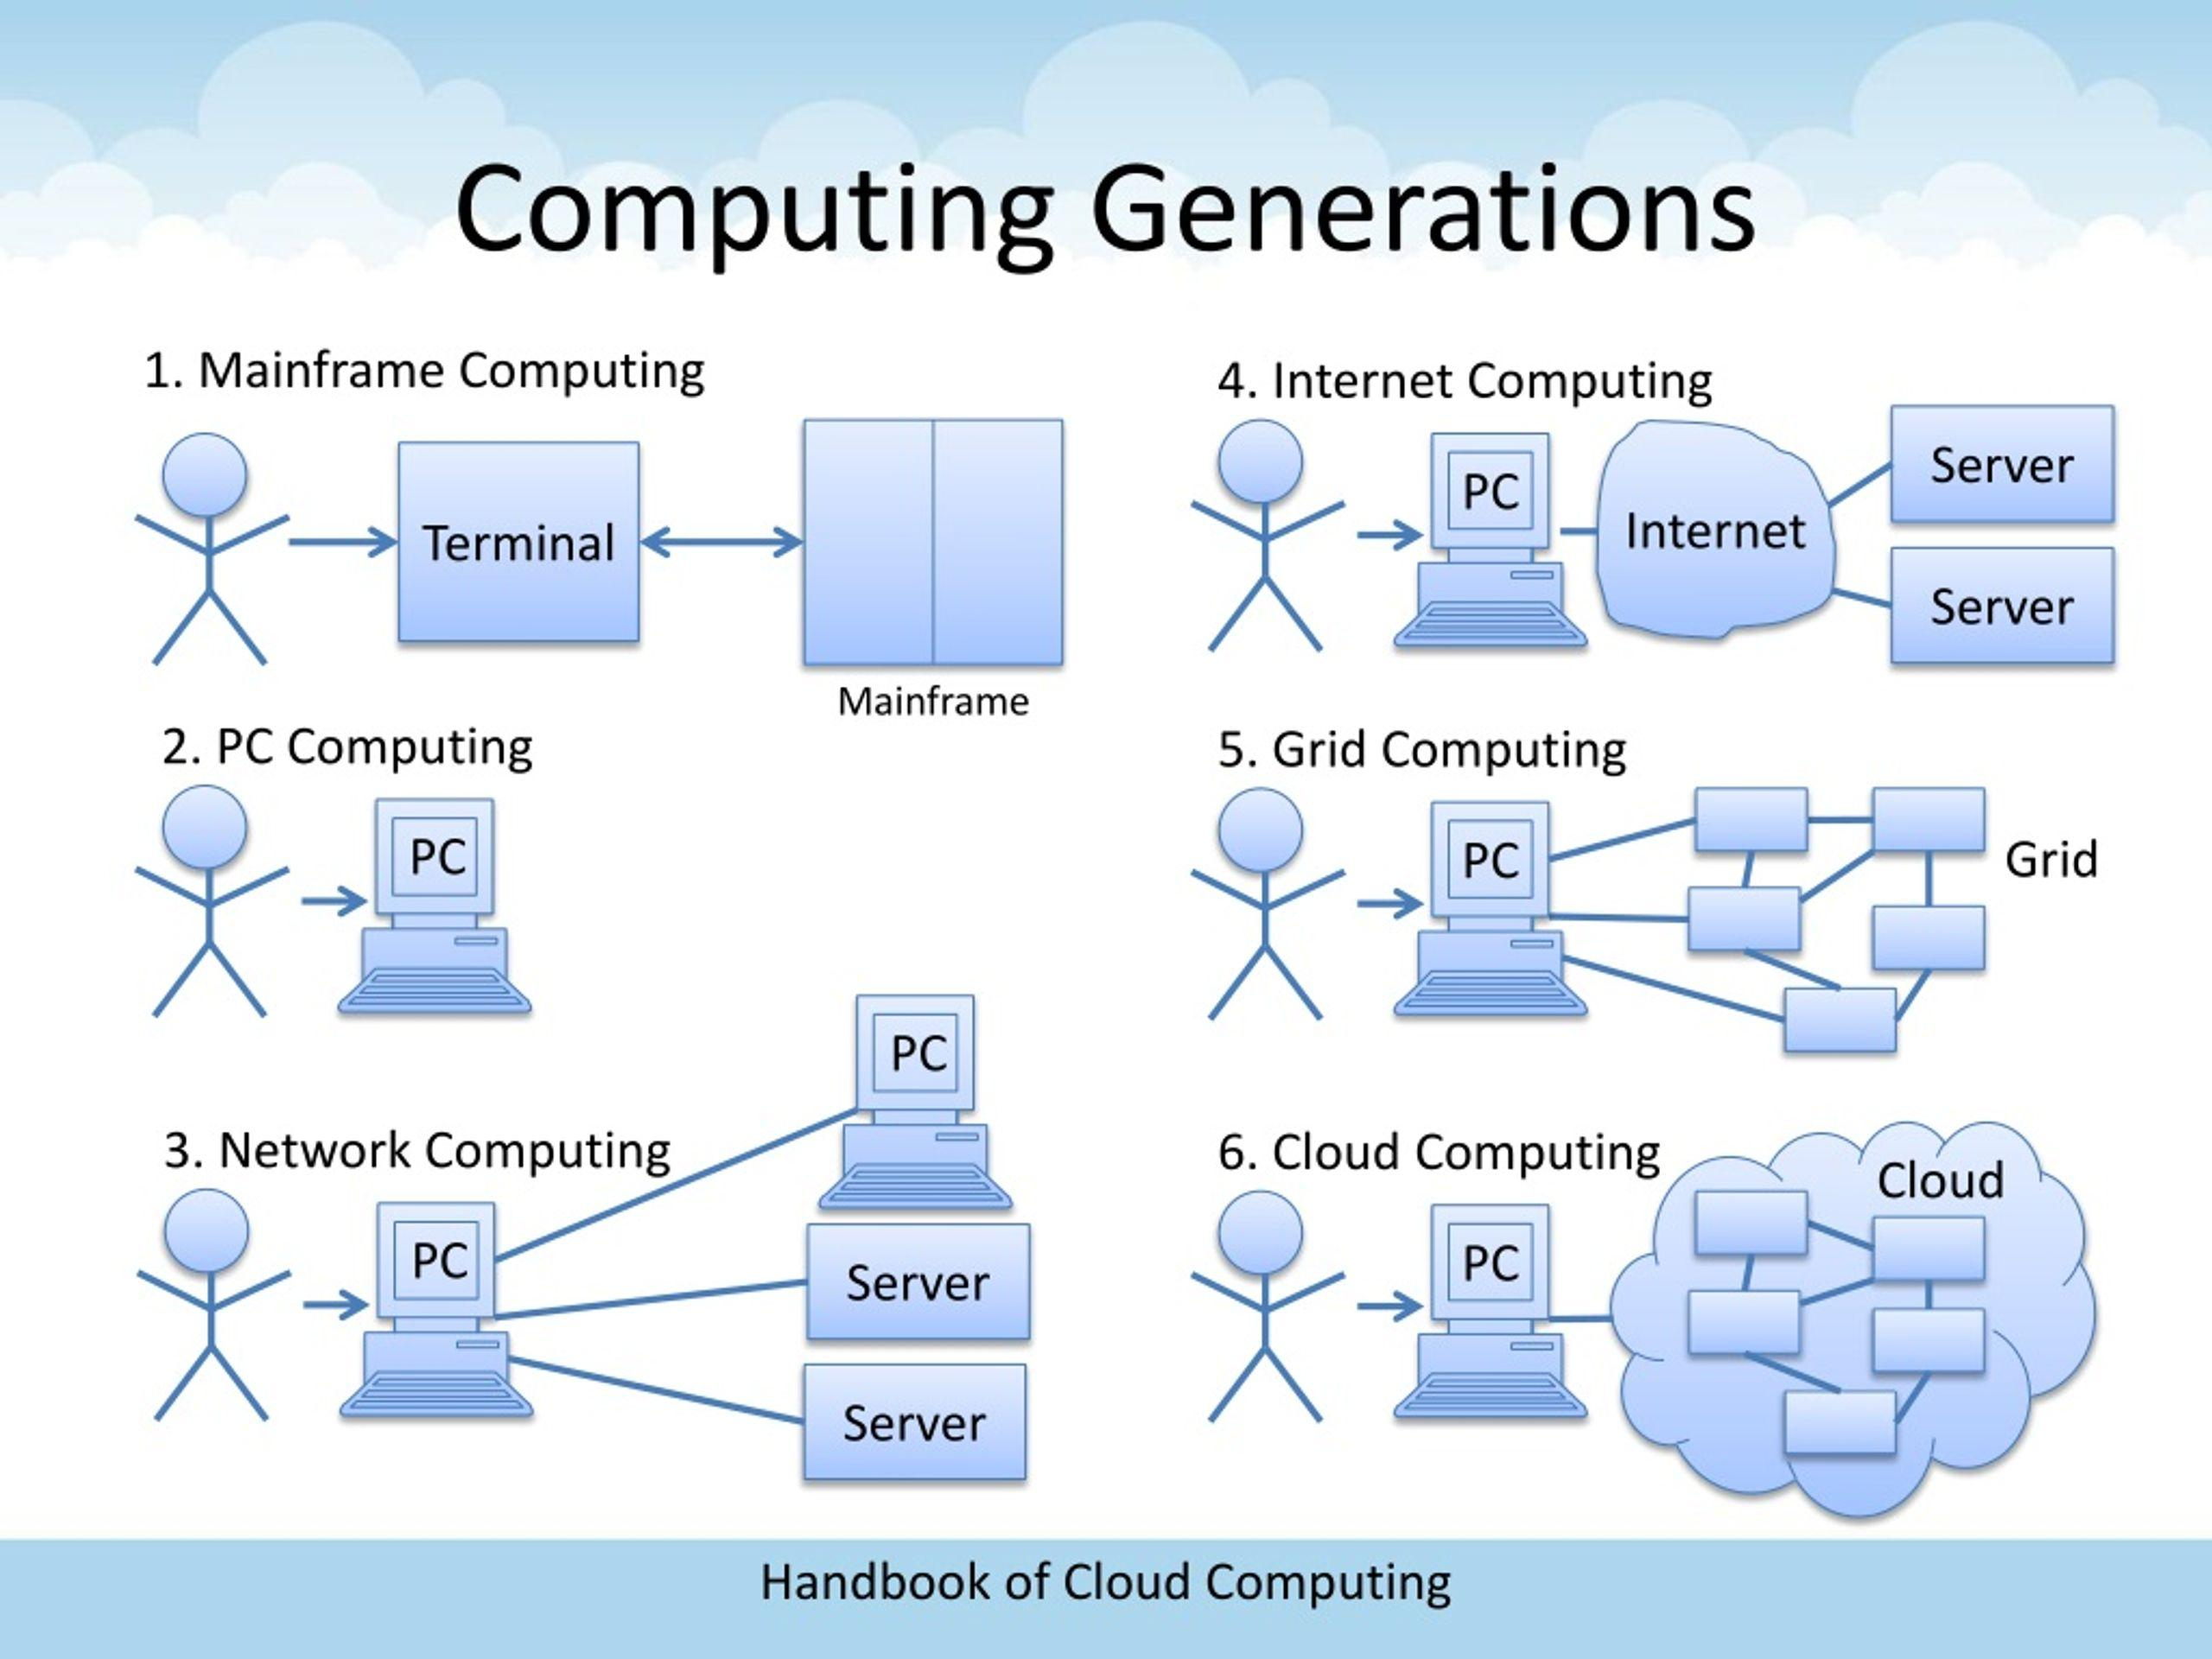
Stage | Period (Approx.) | Description | Limitation Solved
1. Mainframe Computing | 1950s–1960s | Large centralized computers handled data processing for multiple users through terminals. | Reduced dependence on separate computers for every user.
2. Minicomputers | 1960s–1970s | Smaller and less expensive computers provided computing services to departments and organizations. | Reduced the high cost and size of mainframe systems.
3. Personal Computers (PCs) | 1970s–1980s | Individual users could perform computing tasks using their own computers. | Reduced dependence on centralized computing systems.
4. Client–Server Computing | 1980s–1990s | Clients requested services and data from centralized servers through networks. | Enabled centralized data management and resource sharing.
5. Cluster Computing | 1990s | Multiple connected computers worked together as a single computing system. | Improved processing power and system reliability.
6. Grid Computing | Late 1990s–2000s | Distributed computers in different locations shared resources to solve large problems. | Allowed organizations to use geographically distributed computing resources.
7. Utility Computing | 2000s | Computing resources were provided based on usage, similar to electricity or water services. | Introduced pay-per-use computing and reduced infrastructure investment.
8. Cloud Computing | 2006 onwards | Computing resources such as storage, servers, databases, and software are delivered through the internet. | Provides on-demand access, scalability, resource pooling, and flexible payment.

3. Hardware Evolution That Made Cloud Computing Possible
Hardware improvements played an important role in the development of cloud computing.

Hardware Evolution | Description | Contribution to Cloud Computing
1. Multi-Core Processors | Processors contain multiple processing cores to execute tasks simultaneously. | Improves processing speed and supports multiple cloud applications.
2. Commodity Servers | Low-cost, standard servers are used instead of expensive specialized computers. | Reduces infrastructure costs and supports large-scale cloud environments.
3. High-Capacity Storage | Modern HDDs, SSDs, and distributed storage systems provide large storage capacity. | Enables universities to store student records, examination data, videos, and digital learning materials.
4. High-Speed Networking | Advanced networking technologies provide faster data transmission and communication. | Enables users to access cloud applications and services efficiently.
5. Data Centres | Large facilities contain thousands of interconnected servers, storage devices, cooling systems, and networking equipment. | Provides centralized infrastructure, availability, scalability, and reliable cloud services.
4. How Each Stage Solved the Limitations of the Previous Stage
The evolution of computing infrastructure can be understood as follows:
- Mainframes to Minicomputers: Reduced hardware size and cost, making computing more accessible to departments.
- Minicomputers to PCs: Provided individual computing power to users instead of depending entirely on centralized systems.
- PCs to Client–Server: Enabled centralized data storage and communication between multiple computers.
- Client–Server to Clusters: Combined multiple servers to improve processing capacity and reliability.
- Clusters to Grid Computing: Enabled sharing of computing resources across different geographical locations.
- Grid to Utility Computing: Introduced resource usage-based pricing and flexible computing services.
- Utility Computing to Cloud Computing: Combined virtualization, internet connectivity, automation, and resource pooling to provide on-demand computing services.
5. Current Computing Stage of the University
Identified Stage: Client–Server / Traditional On-Premise Computing
The university's current infrastructure most likely corresponds to the traditional client–server computing model, because it depends on physical servers installed and maintained within the campus.
Reasons:
- The university maintains its own physical servers and storage systems.
- Students and faculty access applications through connected client computers.
- Server capacity is limited by the available physical hardware.
- The university must independently manage hardware maintenance, upgrades, and backups.
- Access to certain university applications may be restricted to the campus network.
Limitations of the Current System:
- Difficult to handle sudden increases in student traffic.
- High investment in physical servers and maintenance.
- Limited flexibility in expanding storage and processing resources.
- Difficulties in providing reliable remote access and disaster recovery.
Proposed Improvement: The university should gradually migrate from its traditional client–server infrastructure to a hybrid cloud model. This provides flexible resources, better accessibility, improved scalability, and reduced hardware maintenance.
6. Conclusion
The evolution from mainframe computing to cloud computing was made possible by improvements in processors, storage, networking, virtualization, and data centres. Each stage addressed the limitations of earlier computing systems by improving performance, accessibility, resource sharing, and cost efficiency. The university currently follows a traditional on-premise client–server model and can improve its infrastructure by adopting hybrid cloud computing.
For your 3-mark assignment: Make sure you include the evolution timeline, five hardware developments, how each stage solved previous limitations, and the university's current computing stage with reasons.
TASK 3 – Analyse Internet Software Evolution (3 Marks)
1. Introduction
Internet software has evolved from simple static web pages into advanced cloud-hosted applications. Initially, websites provided only information, but modern internet technologies allow users to interact with applications, store data, share information, and access software through the internet.
This evolution supports cloud computing by allowing applications and services to be delivered through web browsers without requiring users to install complete software on their computers.

2. Evolution of Internet Software
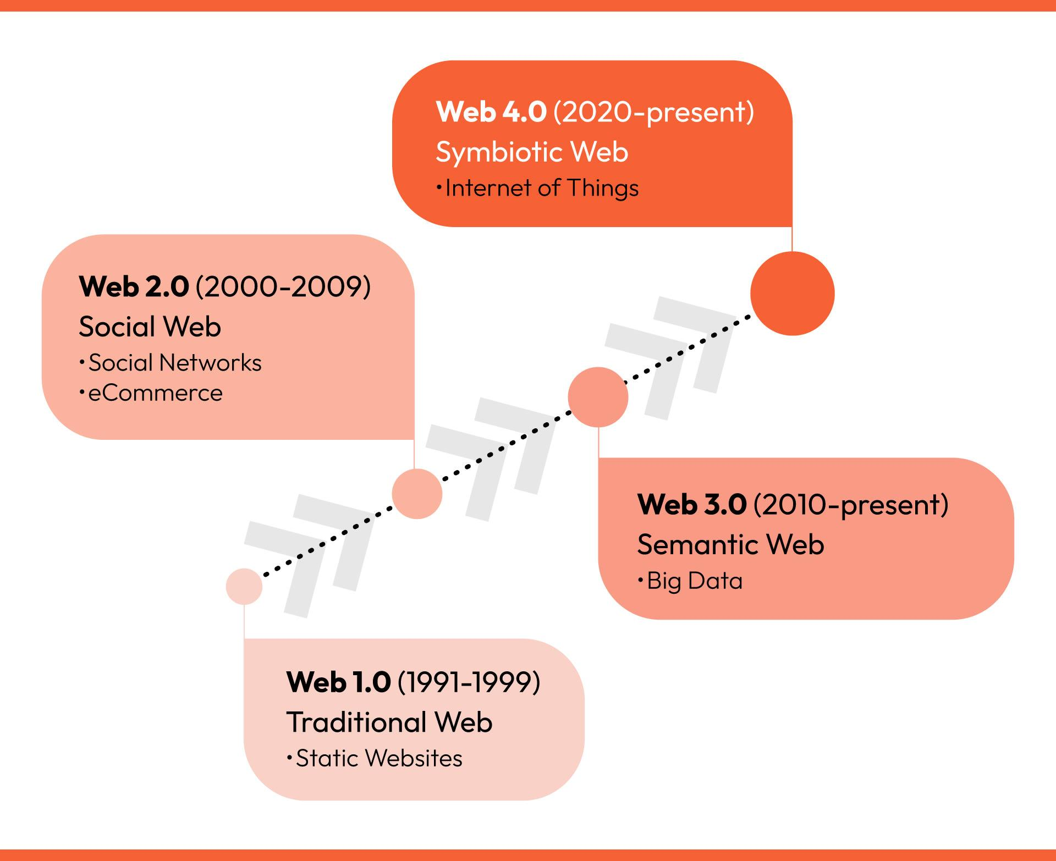
Stage | Description | Example / Contribution
1. Static Web Pages (Web 1.0) | Early websites displayed fixed information using HTML. Users could only read the available content. | Basic university information websites.
2. Dynamic Web | Websites started generating content based on user requests and database information. | Student login portals and online registration systems.
3. Web 2.0 | Introduced interactive websites, collaboration, user-generated content, and social networking. | Google Docs, blogs, and online discussion platforms.
4. Service-Oriented Architecture (SOA) | Applications were divided into independent services that communicate through standard interfaces. | Student management, attendance, and fee payment services working together.
5. Mashups | Combined information or services from multiple sources into one application. | University dashboards combining maps, calendars, and academic information.
6. Cloud-Hosted Applications | Applications are hosted on cloud servers and accessed through the internet. | Google Workspace, Microsoft 365, and cloud-based LMS platforms.

3. Role of Internet Technologies in Supporting Cloud Services
Four important technologies help deliver cloud applications through the internet.
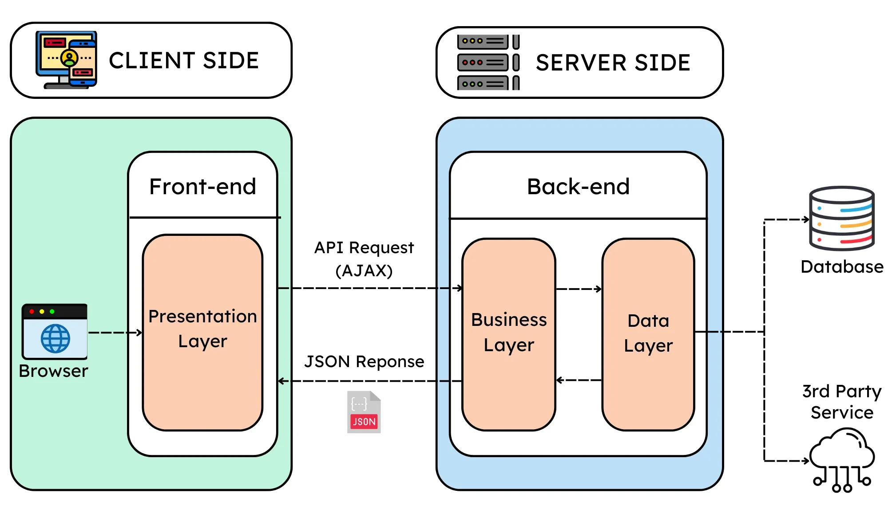
Technology | Role | University Application
1. Web Browsers | Provide an interface to access internet-based applications without installing complete software. | Students access attendance and examination portals through Chrome or Firefox.
2. HTTP/HTTPS | Enables communication between browsers and web servers. HTTPS provides encrypted communication. | Securely transfers student login details and academic information.
3. AJAX | Allows web pages to exchange data with servers asynchronously without reloading the entire page. | Attendance and examination results can be updated dynamically.
4. APIs (Application Programming Interfaces) | Allow different applications and services to communicate and exchange data. | Connects the university's student portal with payment gateways, LMS, and attendance systems.
How they work together:
- The student opens the university website using a web browser.
- The browser sends a request to the cloud server using HTTP/HTTPS.
- The server processes the request and retrieves the required information.
- APIs connect the application with databases and other services.
- AJAX updates the required information on the webpage without refreshing the complete page.
4. Comparison Between Desktop, Client–Server and Web-Delivered Software
Feature | Desktop Software | Client–Server Software | Web-Delivered Software
Installation | Installed directly on individual computers. | Client software and server components are required. | Usually accessed through a web browser.
Accessibility | Mainly available on the installed device. | Available through a connected network. | Accessible from anywhere with internet access.
Data Storage | Usually stored locally. | Stored on a centralized server. | Stored on cloud or hosted servers.
Maintenance | Each computer requires software updates. | Server and client maintenance are required. | Updates are generally managed centrally by the provider.
Scalability | Limited by individual hardware. | Depends on server capacity. | Can scale using cloud resources.
Example | MS Paint, offline calculator. | Traditional university database application. | Google Classroom, Microsoft 365, cloud LMS.
5. Why Internet Software Evolution Supports Cloud Computing
Internet software evolution supports cloud computing in the following ways:
- Remote Accessibility: Users can access applications from different locations through web browsers.
- Centralized Management: Applications and data can be maintained on centralized cloud servers.
- Real-Time Interaction: AJAX enables dynamic updates without reloading entire webpages.
- Application Integration: APIs connect different cloud services and applications.
- Scalability: Cloud-hosted applications can support increasing numbers of users.
- Reduced Installation: Users do not need to install and maintain complete software on every device.
6. Conclusion
Internet software evolved from static web pages to dynamic websites, Web 2.0, SOA, mashups, and cloud-hosted applications. Technologies such as browsers, HTTP/HTTPS, AJAX, and APIs enable communication, interaction, and integration between users and cloud services. Compared with traditional desktop and client–server software, web-delivered applications provide better accessibility, centralized maintenance, and scalability. Therefore, internet software evolution plays an important role in making cloud computing possible.
Important points for your 3-mark assignment:
- Evolution: Static Web → Dynamic Web → Web 2.0 → SOA → Mashups → Cloud Applications.
- Technologies: Browsers, HTTP/HTTPS, AJAX, APIs.
- Comparison: Desktop vs Client–Server vs Web-Delivered Software.
- University example: Cloud-based student portal, attendance, examination, and LMS.
TASK 4 – Apply Server Virtualization (5 Marks)
1. Introduction to Server Virtualization
Server virtualization is a technology that allows multiple virtual servers to run on a single physical server. It uses software called a hypervisor to divide the physical server's resources, such as CPU, RAM, storage, and networking, among multiple Virtual Machines (VMs).
In the university scenario, there are 12 physical servers. Instead of maintaining all 12 servers separately, virtualization can consolidate their workloads into fewer powerful physical hosts. This reduces hardware costs, electricity consumption, maintenance, and space requirements.
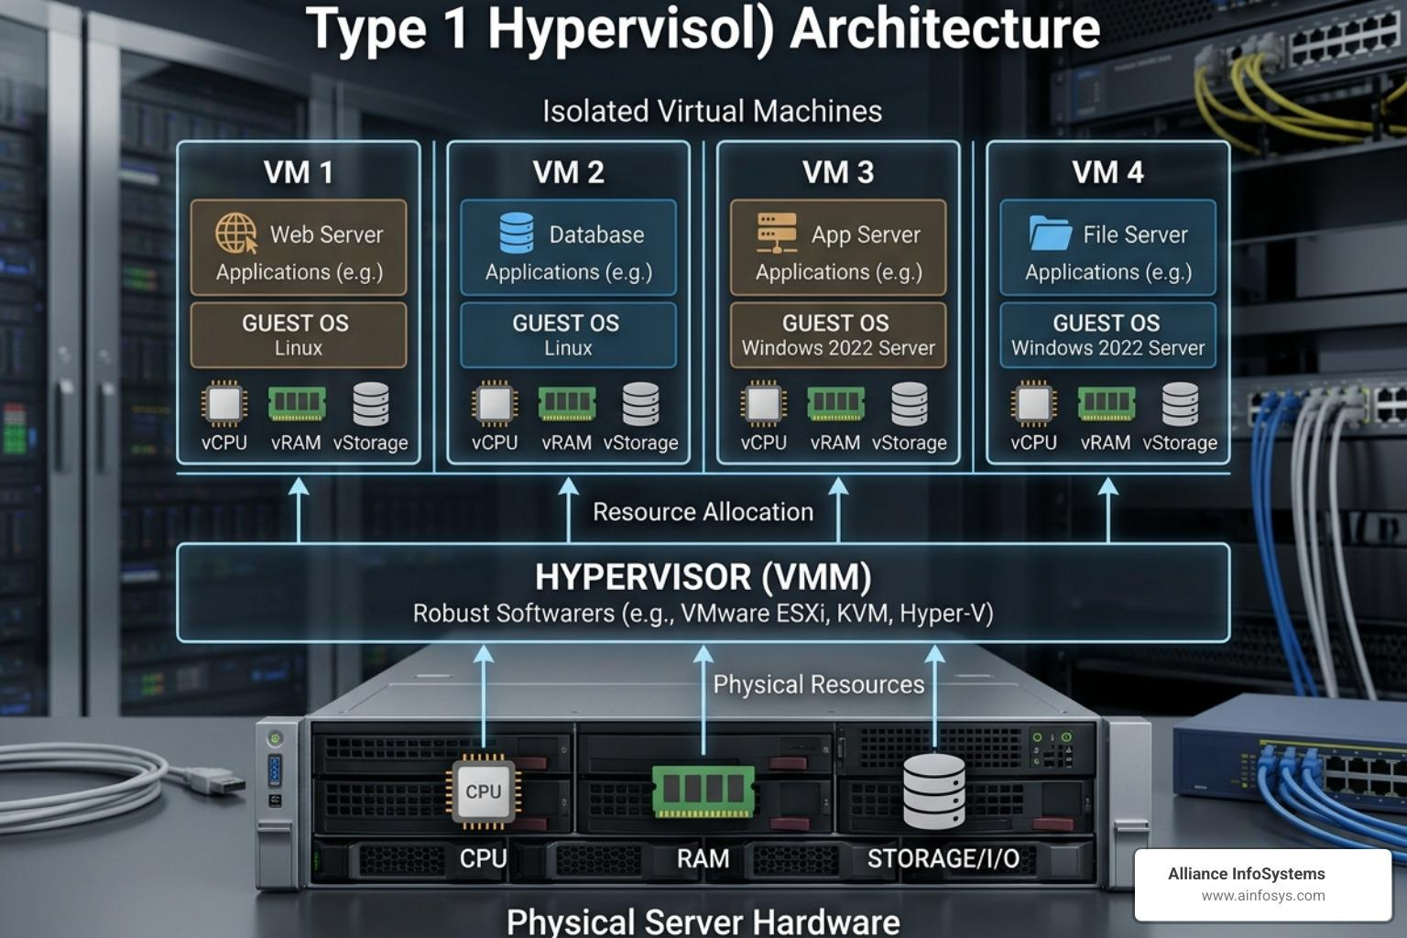2. How a Hypervisor Works
A hypervisor is software or firmware that creates and manages multiple virtual machines on one physical server.
Working process:
- The physical server provides CPU, RAM, storage, and network resources.
- The hypervisor manages and allocates these resources.
- Multiple virtual machines are created on the physical server.
- Each VM runs its own operating system and applications.
- The hypervisor ensures that VMs operate independently while sharing physical hardware.

Types of Hypervisors
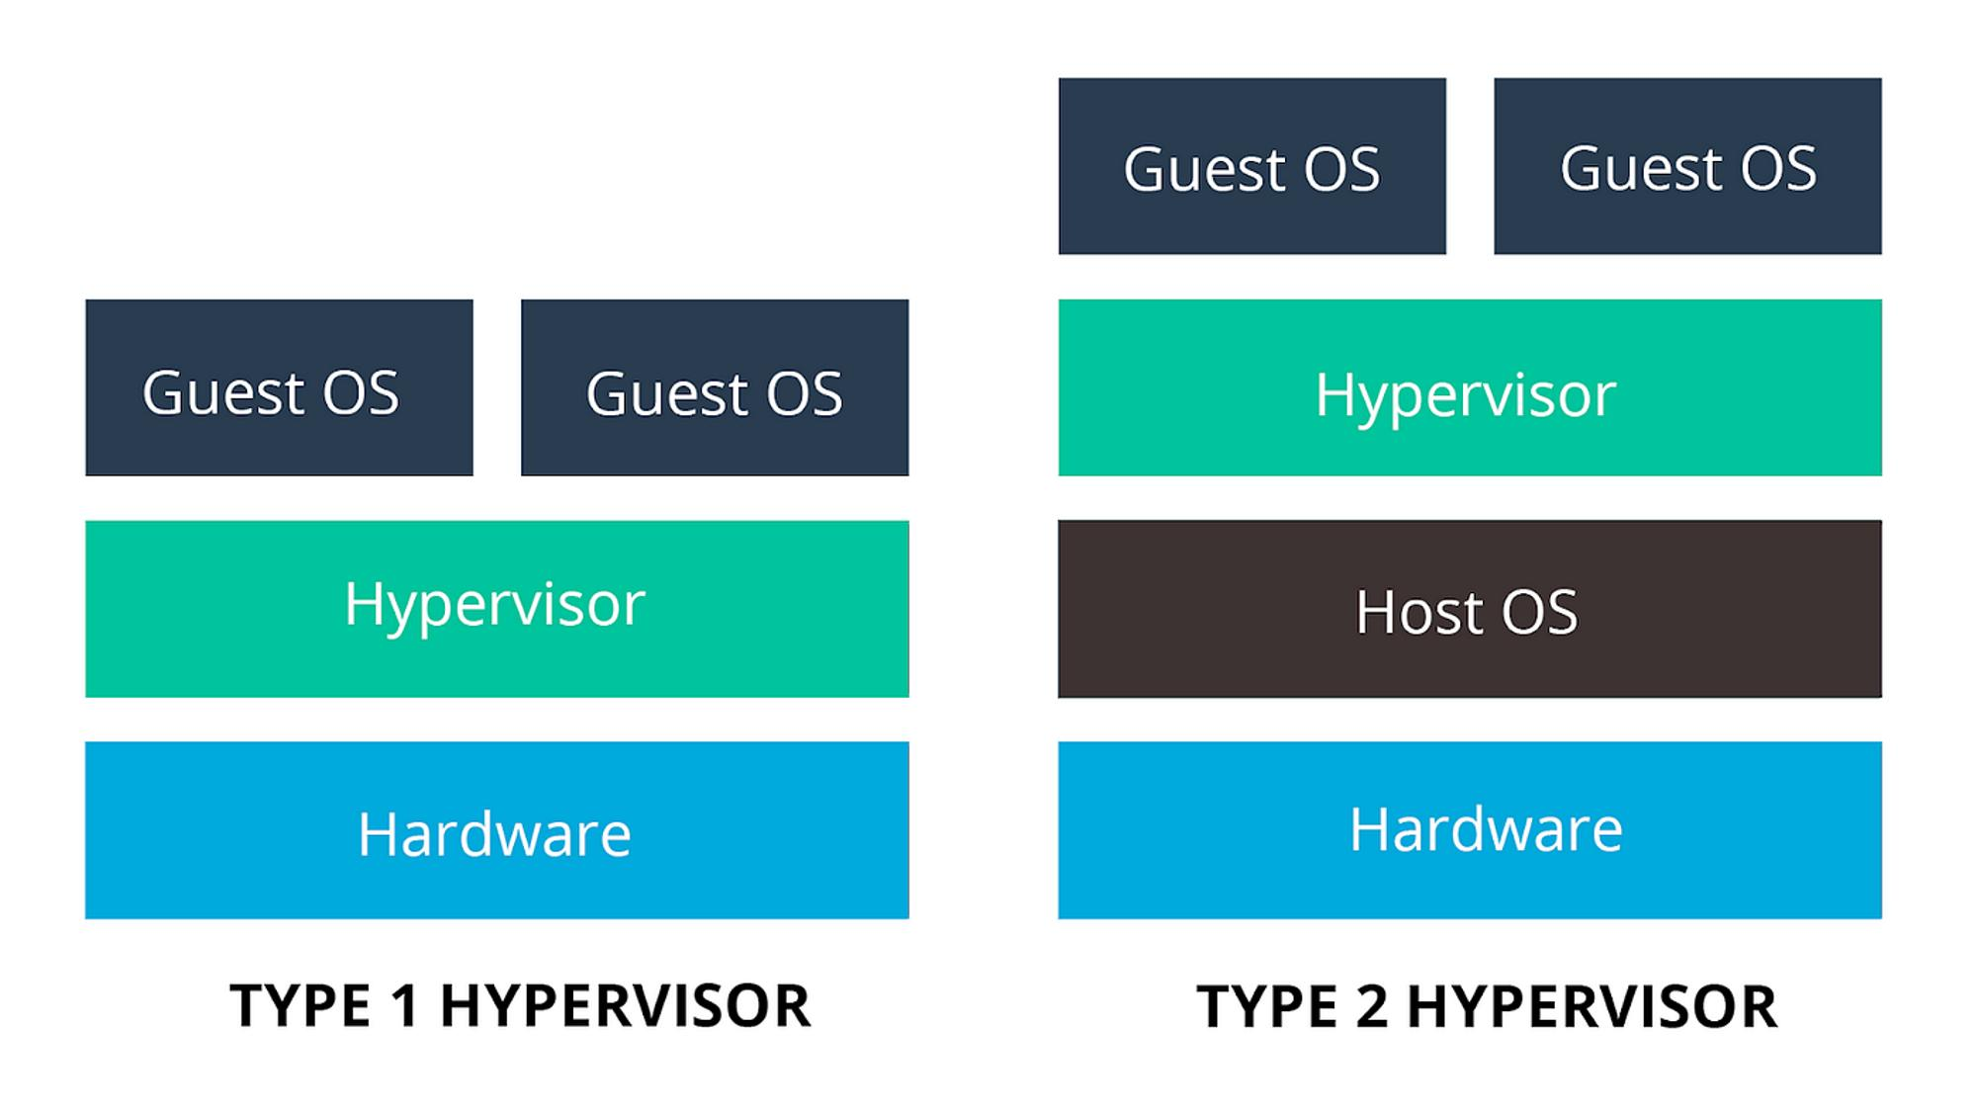
Feature | Type-1 Hypervisor | Type-2 Hypervisor
Meaning | Runs directly on physical hardware. | Runs on top of a host operating system.
Performance | Generally provides better performance. | Has additional overhead from the host OS.
Security | Provides a dedicated virtualization layer. | Depends partly on the host OS security.
Usage | Enterprise servers and data centres. | Personal computers, testing, and development.
Examples | VMware ESXi, Microsoft Hyper-V, Xen. | Oracle VirtualBox, VMware Workstation.
Recommended for the university: Type-1 hypervisors are preferred because they provide better performance, centralized management, and suitability for large-scale server consolidation.

3. Comparison of Virtualization Techniques
There are four major virtualization techniques.
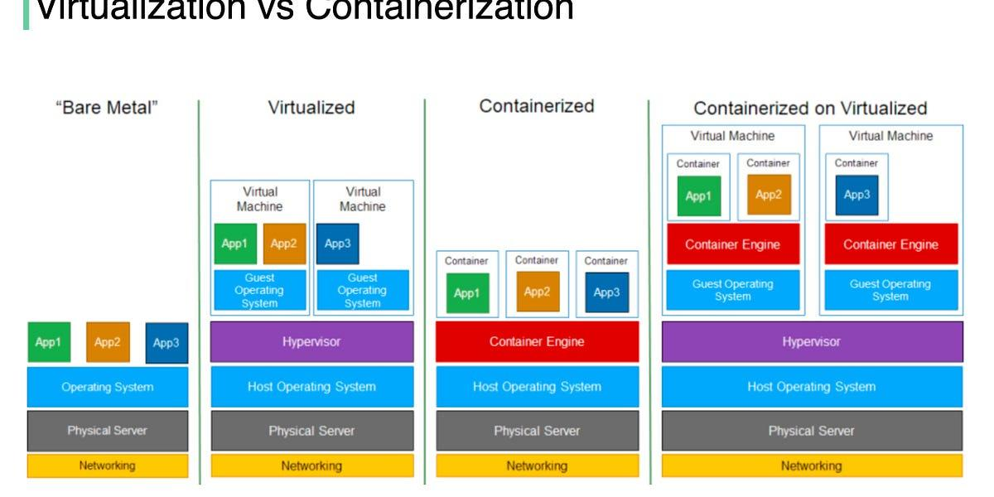
Technique | Explanation | Advantages | Example
Full Virtualization | Creates a complete virtual hardware environment in which an unmodified guest OS runs. | Strong isolation and supports different operating systems. | VMware ESXi, KVM.
Para-Virtualization | The guest operating system is modified to communicate with the hypervisor using special interfaces. | Reduces virtualization overhead in supported environments. | Xen PV.
OS-Level Virtualization (Containers) | Multiple isolated containers share the same host operating system kernel. | Lightweight, fast startup, and efficient resource usage. | Docker, LXC.
Hardware-Assisted Virtualization | Uses processor features such as Intel VT-x and AMD-V to support virtualization. | Improves VM execution and reduces software virtualization overhead. | KVM with Intel VT-x or AMD-V.
Note: Hardware-assisted virtualization is a hardware-supported method that can be used with full virtualization. These techniques are not necessarily mutually exclusive.

4. Proposed Application Allocation: Virtual Machines vs Containers
The university should use both virtual machines and containers depending on application requirements.
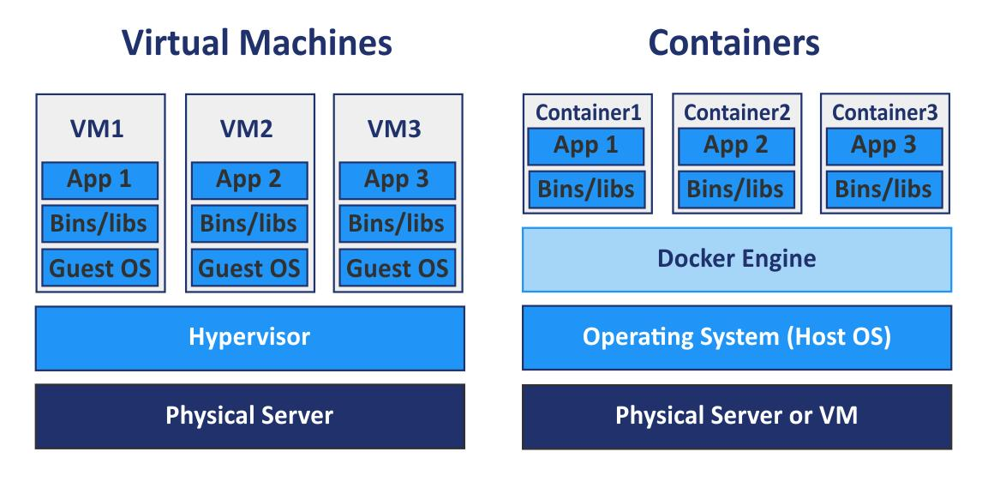

University Application | Recommended Technology | Reason
Student Information System | Virtual Machine | Requires an independent operating system and reliable data management.
Examination Management System | Virtual Machine | Needs strong isolation and secure examination processing.
Finance and Fee Management | Virtual Machine | Handles sensitive financial information.
University Website | Container | Lightweight and can handle changing web traffic.
Learning Management System (LMS) | Containers | Supports scalable application deployment.
Attendance Management Application | Container | Can be deployed and updated easily.
API and Authentication Services | Containers | Supports independent deployment and scaling.
Database Server | Virtual Machine | Provides dedicated resources and persistent storage management.
Proposed approach: Use VMs for critical and legacy applications that require independent operating systems. Use containers for modern web applications and microservices that need fast deployment and scalability.
5. Server Consolidation Calculation
Given:
- Total physical servers = 12
- Average utilization of each server = 15%
- Target utilization of each new physical host = 70%
- Assume all physical servers have equal processing capacity.
Step 1: Calculate total workload
\[ \text{Total Workload}=12\times15\% \]
\[ =180\% \]
Therefore, the combined workload is equal to 1.8 fully utilized server capacities.
Step 2: Calculate the number of required physical hosts
\[ \text{Required Hosts}= \frac{\text{Total Workload}}{\text{Target Host Utilization}} \]
\[ =\frac{180}{70}=2.57 \]
Step 3: Round up to the next whole number
\[ \boxed{\text{Required Physical Hosts}=3} \]
Final Result: 3 Physical Hosts
Step 4: Calculate the reduction in physical servers
\[ \text{Servers Saved}=12-3=9 \]
\[ \text{Reduction}=\frac{9}{12}\times100=75\% \]
Physical Server Consolidation
Comparison of physical servers before and after virtualization.
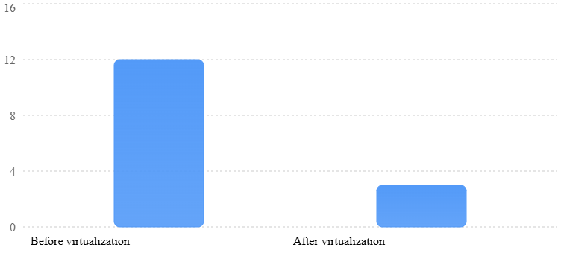
Result: The university can consolidate 12 physical servers into 3 physical hosts, achieving a 75% reduction in physical server count under the stated assumptions.
Note: This calculation does not include an additional host for N+1 high availability. If the university requires one host to remain available during a failure, additional capacity planning is necessary.
6. Benefits of Server Virtualization
- Live Migration: Moves a running virtual machine from one physical host to another with minimal service interruption.
- Snapshots: Saves the state of a virtual machine at a particular point in time, allowing recovery to that state when needed.
- Resource Over-Commitment: Allows allocation of more virtual CPU or memory resources than the physical capacity, based on expected usage and monitoring.
- Cost Reduction: Reduces hardware purchases, electricity consumption, and maintenance expenses.
- Better Resource Utilization: Multiple applications share available physical server resources efficiently.

7. Risks and Challenges of Virtualization
Risk | Explanation | Possible Solution
Noisy Neighbour | One VM consumes excessive CPU, memory, or storage, affecting other VMs. | Apply resource limits and monitor workloads.
Hypervisor Failure | Failure of the hypervisor can affect all VMs running on that host. | Use high availability and backup hosts.
Security Isolation | Improper configuration or hypervisor vulnerabilities may allow security threats to affect other VMs. | Apply security patches, access controls, and isolation policies.
Resource Over-Commitment | Excessive allocation can cause memory shortages and performance problems. | Monitor resource usage and maintain sufficient capacity.
Data Loss | Hardware failure or incorrect snapshot management can result in data loss. | Maintain regular independent backups and recovery plans.
8. Conclusion
Server virtualization helps the university improve its IT infrastructure by combining multiple physical servers into fewer powerful hosts. By using Type-1 hypervisors, virtual machines, and containers, the university can improve resource utilization, reduce hardware costs, and simplify server management. Based on the given utilization values, 12 physical servers can be consolidated into approximately 3 physical hosts, achieving a 75% reduction in physical server count. However, proper security, backup, and resource monitoring are essential for reliable virtualization.
TASK 5 – Apply Web Services (4 Marks)
1. Introduction to Web Services
A web service is a software component that allows two different applications to communicate and exchange data over a network using standard protocols such as HTTP/HTTPS.
Web services help universities connect different systems, such as student management, examination management, fee payment, library management, and learning management systems.
Example: A student can check examination results through a university website, which communicates with the examination database using a web service.
Role of Web Services in Cloud Computing and SOA
- Cloud Computing: Web services allow users to access university applications and data through the internet.
- Service-Oriented Architecture (SOA): Different university functions are developed as independent services that communicate with one another.
- Application Integration: Connects different applications, databases, and external systems.
- Reusability: The same service can be used by multiple applications.
- Scalability: Individual services can be maintained and scaled according to demand.
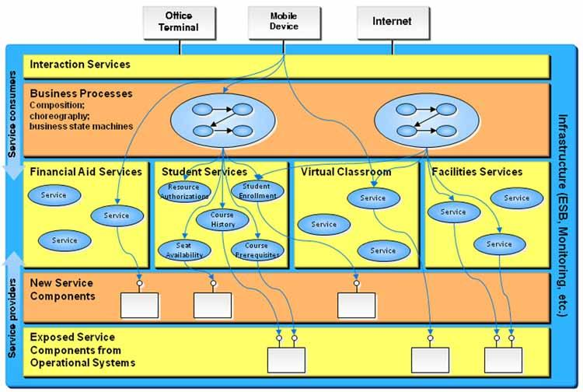
2. Comparison of SOAP, WSDL, UDDI and RESTful Services
These technologies and standards support web service communication and discovery.
Technology | Full Form | Description | Data Format / Protocol
SOAP | Simple Object Access Protocol | A protocol used for structured communication between applications. | XML
WSDL | Web Services Description Language | Describes a web service, including its operations, messages, and endpoint details. | XML
UDDI | Universal Description, Discovery and Integration | A directory standard used to publish and discover web services. | XML-based registry
REST | Representational State Transfer | An architectural style that uses HTTP methods to access and manipulate resources. | Mainly JSON; also XML and other formats
RESTful Service HTTP Methods
HTTP Method | Purpose | University Example
GET | Retrieves information. | Get student results.
POST | Creates or submits information. | Submit a fee payment request.
PUT | Updates an existing resource completely. | Update student profile details.
PATCH | Updates selected fields of a resource. | Change student contact details.
DELETE | Deletes a resource. | Remove an authorized library reservation.
SOAP vs REST
Feature | SOAP | REST
Type | Communication protocol | Architectural style
Data Format | XML only | Mainly JSON, also XML
Transport | HTTP/HTTPS and other supported protocols | Primarily HTTP/HTTPS
Performance | Generally more message overhead | Generally lightweight and faster
Security | Supports WS-Security standards | Commonly uses HTTPS, OAuth 2.0 and other security mechanisms
Complexity | More complex | Simpler to develop and integrate
Best Use | Enterprise transactions and strict messaging requirements | Web applications, mobile apps, and cloud APIs
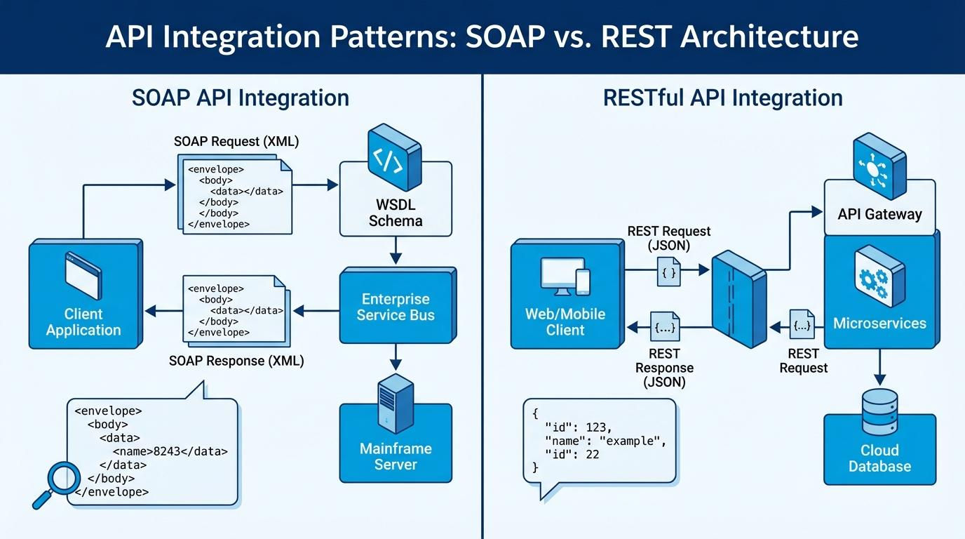3. University Functions Exposed as Web Services
The university can expose several functions as web services so that students, faculty, and external applications can access them securely.
Service 1: Student Result Lookup
Purpose: Allows students to view their examination results using their registration number and semester.
- Endpoint: GET /api/students/{regNo}/results?semester=5
- Method: GET
- Technology: REST
- Response format: JSON
Sample Request:
GET /api/students/192525345/results?semester=5
Sample Response:
{
"regNo": "192525345",
"studentName": "I. Jaswanth",
"semester": 5,
"subjects": [
{
"subject": "Cloud Computing",
"grade": "A",
"result": "PASS"
},
{
"subject": "DBMS",
"grade": "A+",
"result": "PASS"
}
],
"status": "SUCCESS"
}
Justification: REST is suitable because result lookup mainly retrieves information. GET requests and JSON responses are lightweight and easy to integrate with mobile applications.
Service 2: Fee Payment
Purpose: Allows students to submit fee payment requests through the university portal.
- Endpoint: POST /api/payments
- Method: POST
- Technology: REST
- Request/Response format: JSON
Sample Request:
{
"regNo": "192525345",
"amount": 25000,
"paymentType": "Semester Fee",
"paymentMethod": "UPI"
}
Sample Response:
{
"paymentId": "PAY10245",
"regNo": "192525345",
"amount": 25000,
"status": "SUCCESS",
"message": "Payment completed successfully"
}
Justification: REST is suitable because it supports simple HTTP communication and JSON integration with payment gateways. The actual payment must be verified by the payment provider before marking it successful. Secure authentication, HTTPS, and transaction verification are essential.
Service 3: Library Search
Purpose: Allows students and faculty to search for books, check availability, and find library resources.
- Endpoint: GET /api/library/books?title=Cloud+Computing
- Method: GET
- Technology: REST
- Response format: JSON
Sample Request:
GET /api/library/books?title=Cloud+Computing
Sample Response:
{
"searchTitle": "Cloud Computing",
"books": [
{
"bookId": "B101",
"title": "Introduction to Cloud Computing",
"author": "John Smith",
"availability": "Available"
},
{
"bookId": "B102",
"title": "Cloud Infrastructure",
"author": "David Brown",
"availability": "Issued"
}
],
"status": "SUCCESS"
}
Justification: REST is suitable because library searches mainly involve retrieving information. GET requests provide quick responses and JSON makes integration with web and mobile applications easier.
Service 4: Student Certificate Verification
Purpose: Allows external organizations or other institutions to verify student academic certificates securely.
- Service endpoint: https://university.edu/services/CertificateVerification
- Technology: SOAP
- Request/Response format: XML
Sample SOAP Request:
<soap:Envelope
xmlns:soap="http://schemas.xmlsoap.org/soap/envelope/">

<soap:Body>
<VerifyCertificate>
<RegistrationNumber>192525345</RegistrationNumber>
<CertificateID>CERT1025</CertificateID>
</VerifyCertificate>
</soap:Body>

</soap:Envelope>
Sample SOAP Response:
<soap:Envelope
xmlns:soap="http://schemas.xmlsoap.org/soap/envelope/">

<soap:Body>
<VerifyCertificateResponse>
<RegistrationNumber>192525345</RegistrationNumber>
<CertificateStatus>VALID</CertificateStatus>
<VerificationStatus>SUCCESS</VerificationStatus>
</VerifyCertificateResponse>
</soap:Body>

</soap:Envelope>
Justification: SOAP is suitable when the university integrates with legacy institutional systems that require strict XML message formats, formal service contracts through WSDL, and enterprise security standards.
4. Summary of Proposed University Web Services
University Function | Endpoint | HTTP Method | Recommended Technology
Student Result Lookup | /api/students/{regNo}/results | GET | REST
Fee Payment | /api/payments | POST | REST
Library Search | /api/library/books | GET | REST
Certificate Verification | /services/CertificateVerification | SOAP operation | SOAP
5. Security Requirements for University Web Services
- Authentication: Verify users before providing access to university services.
- Authorization: Allow students, faculty, and administrators to access only their permitted services.
- HTTPS Encryption: Protect information exchanged between applications.
- Input Validation: Validate registration numbers, payment amounts, and user inputs.
- Audit Logging: Maintain records of result access, payment transactions, and certificate verification.
6. Conclusion
Web services play an important role in connecting university applications through cloud computing and Service-Oriented Architecture. SOAP provides structured XML-based communication, while REST provides lightweight communication using HTTP methods and JSON. For the university, REST is more suitable for result lookup, fee payment, and library search, whereas SOAP can be used for certificate verification with legacy enterprise systems. Implementing these services improves application integration, accessibility, reusability, and overall university management.
Important points for your 4-mark assignment:
- Definition and role of web services in cloud computing and SOA.
- Comparison of SOAP, WSDL, UDDI, and REST.
- HTTP methods: GET, POST, PUT, PATCH, DELETE.
- Four university web services with endpoints and sample requests/responses.
- Justification for choosing REST or SOAP.
- Security requirements and conclusion.
TASK 6 – Analyse the Service Models: IaaS, PaaS and SaaS (5 Marks)
1. Introduction to Cloud Service Models
Cloud computing provides three major service models: Infrastructure as a Service (IaaS), Platform as a Service (PaaS), and Software as a Service (SaaS).
These models differ in how cloud resources are provided and how responsibilities are shared between the cloud service provider and the university.
- IaaS: Provides virtual servers, storage, and networking through the internet.
- PaaS: Provides a platform and development environment to build, test, deploy, and manage applications.
- SaaS: Provides ready-to-use software applications through the internet without requiring users to manage the underlying infrastructure.
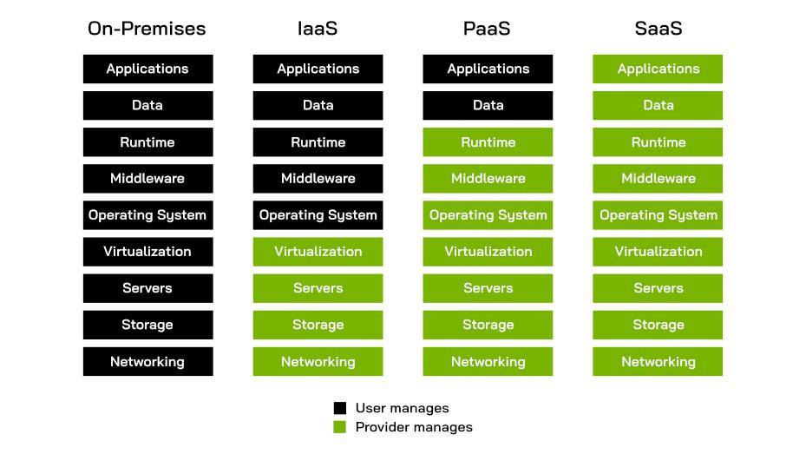2. Layer-Wise Responsibility Comparison
Cloud service models distribute management responsibilities between the cloud provider and the university.
Computing Layer | IaaS | PaaS | SaaS
Physical Hardware | Provider | Provider | Provider
Networking | Provider | Provider | Provider
Storage | Provider | Provider | Provider
Virtualization | Provider | Provider | Provider
Operating System | University | Provider | Provider
Middleware / Runtime | University | Provider | Provider
Application | University | University | Provider
Application Data and Configuration | University | University | Shared responsibility
Explanation:
- IaaS: The provider manages physical infrastructure, while the university manages the operating system, installed software, applications, and data.
- PaaS: The provider manages infrastructure, operating systems, middleware, and runtime environments. The university focuses on developing applications and managing its data.
- SaaS: The provider manages the complete application and underlying infrastructure. The university mainly manages user access, settings, and its data-related responsibilities.
Note: The table represents a typical responsibility model. Exact responsibilities vary by provider, service configuration, and contract.
3. Categorisation of Five University Applications
The university has five major applications: Student Information System (SIS), Learning Management System (LMS), Library Management System, Examination Portal, and Email System.
The following table recommends a suitable cloud service model for each application.
University Application | Recommended Model | Reason
Student Information System (SIS) | IaaS | Requires greater control over student records, database configuration, and application security.
Learning Management System (LMS) | PaaS | Supports custom development, integration, and deployment of educational applications.
Library Management System | SaaS | Ready-made library management software can handle book records, borrowing, returns, and searches.
Examination Portal | IaaS | Requires greater control over examination infrastructure, security configuration, and server resources.
University Email System | SaaS | Ready-to-use email services reduce installation, maintenance, and infrastructure management.
4. Reasoning Behind Each Application Decision
1. Student Information System (SIS) – IaaS
The Student Information System manages student registration, attendance, academic records, personal information, and examination results.
Why IaaS is suitable:
- Provides control over the operating system and database configuration.
- Allows the university to customize the application according to its requirements.
- Supports secure storage and management of sensitive student information.
- Provides flexible computing and storage resources as student numbers increase.
Example provider: Amazon EC2.
2. Learning Management System (LMS) – PaaS
The Learning Management System provides online classes, assignments, study materials, quizzes, and communication between students and faculty.
Why PaaS is suitable:
- Provides a ready development and deployment environment.
- Allows developers to customize learning applications.
- Supports integration with video conferencing, databases, and student portals through APIs.
- Automatically manages much of the underlying infrastructure.
Example provider: Google App Engine.
3. Library Management System – SaaS
The Library Management System manages books, digital resources, borrowing, returns, and availability information.
Why SaaS is suitable:
- Ready-made library software reduces development time.
- Students can search books through a web browser.
- Software updates and infrastructure maintenance are handled by the provider.
- Reduces the university's hardware and maintenance expenses.
Example: A hosted library management service such as Koha offered through a managed hosting provider.
4. Examination Portal – IaaS
The Examination Portal handles online examinations, question papers, student submissions, and examination records.
Why IaaS is suitable:
- Provides control over server configurations and security settings.
- Allows additional computing resources during examination periods.
- Supports customized examination applications.
- Provides flexibility to configure databases, backups, and monitoring.
Example provider: Microsoft Azure Virtual Machines.
5. University Email System – SaaS
The email system supports communication between students, faculty, administrators, and departments.
Why SaaS is suitable:
- Provides ready-to-use email services.
- Users can access email from laptops and smartphones.
- Automatic software updates and maintenance reduce IT workload.
- Provides built-in spam filtering, storage, and collaboration features.
Example provider: Google Workspace for Education.
5. Comparison of IaaS, PaaS and SaaS
Comparison Factor | IaaS | PaaS | SaaS
Control | High control over OS, storage, and applications. | Medium control over applications and data. | Limited control over underlying software.
Cost | Pay for virtual machines, storage, and networking. | Pay for platform resources and usage. | Usually subscription-based pricing.
Scalability | Resources can be increased or decreased as required. | Supports application scaling through platform services. | Provider manages scaling based on service capacity and plan.
Maintenance Effort | High; university manages OS and applications. | Medium; provider manages platform and infrastructure. | Low; provider manages application and infrastructure.
Vendor Lock-in | Generally lower, but depends on infrastructure services used. | Higher due to platform-specific tools and services. | Can be high due to proprietary data formats and application features.
Explanation of the Comparison
- Control: IaaS provides maximum flexibility, whereas SaaS provides the least control over the underlying system.
- Cost: IaaS requires infrastructure usage payments, PaaS charges for platform resources, and SaaS generally uses subscription-based pricing.
- Scalability: All three models support scalability, but the level of management differs.
- Maintenance: IaaS requires more technical maintenance, while SaaS requires minimal infrastructure maintenance from the university.
- Vendor Lock-in: Moving between providers may be easier with standard IaaS infrastructure, while PaaS and SaaS may depend on provider-specific technologies and services.
6. Real-World Cloud Provider Examples
AWS Signature Version 4 - Overview (ODC) | OutSystems
IaaS – Amazon Web Services (AWS)
Provides virtual servers through Amazon EC2, storage through Amazon S3, and networking services.
Website: AWS Official Website
Google Cloud to provide AI and cloud services to Brazilian energy firm Eneva - DCD
PaaS – Google Cloud
Provides Google App Engine for developing and deploying applications without managing physical servers.
Website: Google Cloud Official Website
Microsoft 365 Business Standard - Software ufficio - LDLC | Misericordia
SaaS – Microsoft 365
Provides ready-to-use applications such as Outlook, Word, Excel, and Teams through the internet.
Website: Microsoft 365 Official Website
7. Conclusion
IaaS, PaaS, and SaaS provide different levels of control, flexibility, and maintenance in cloud computing. For the university, IaaS is suitable for the Student Information System and Examination Portal because they require greater infrastructure control. PaaS is suitable for the Learning Management System because it supports application development and integration. SaaS is suitable for Library Management and Email services because ready-made applications reduce development and maintenance efforts.
Therefore, combining all three cloud service models provides a flexible, scalable, cost-effective, and efficient solution for the university's digital infrastructure.
Important points for your 5-mark assignment:
- Definitions of IaaS, PaaS, and SaaS.
- Layer-wise responsibility comparison.
- Categorisation of all five university applications with reasons.
- Comparison based on control, cost, scalability, maintenance, and vendor lock-in.
- Real-world providers: AWS, Google Cloud, and Microsoft 365.
Evidence note: The application mapping is a proposed design, not a fixed rule. The same application could use another service model depending on whether the university chooses to develop, host, or purchase it.
TASK 7 – Examine XaaS (Anything-as-a-Service) (3 Marks)
1. Introduction to XaaS
XaaS (Anything-as-a-Service) is a cloud computing concept in which different IT resources, software, platforms, and infrastructure are provided to users as services through the internet.
Instead of purchasing and maintaining expensive hardware and software, an organization can access the required services from cloud providers on a subscription or pay-per-use basis.
Example: A university can use cloud databases, online backup services, security services, and application development platforms without maintaining all the infrastructure on campus.
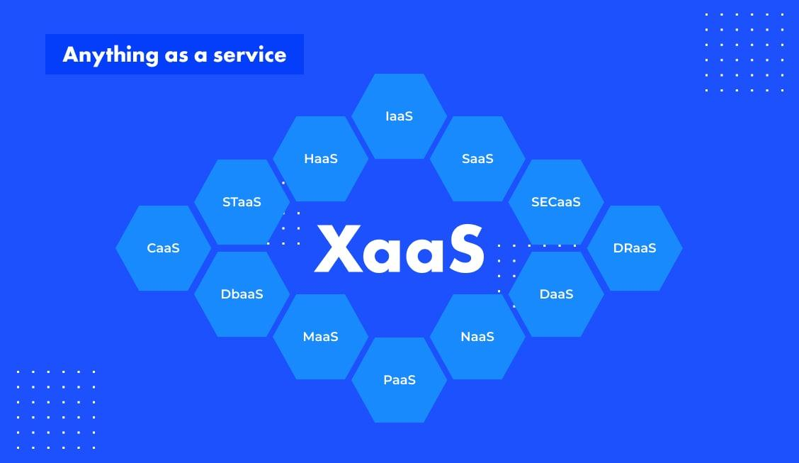
2. Different Variants of XaaS
XaaS includes several service categories that provide specific IT functions.
XaaS Variant | Full Form | Description | University Application
1. DaaS | Desktop as a Service | Provides virtual desktops through the internet. | Students and faculty can access virtual desktops from anywhere.
2. BaaS / MBaaS | Backend as a Service / Mobile Backend as a Service | Provides backend services such as authentication, notifications, and data synchronization. | Supports university mobile applications for attendance and notifications.
3. FaaS | Function as a Service | Executes individual code functions when triggered without managing servers. | Sends automatic attendance alerts and examination notifications.
4. DBaaS | Database as a Service | Provides managed cloud databases without maintaining database servers. | Stores student records, attendance, library details, and examination data.
5. Security as a Service | Security services delivered through the cloud. | Protects applications, networks, and data using managed security tools. | Provides threat detection, access monitoring, and protection against cyberattacks.
6. DRaaS | Disaster Recovery as a Service | Provides cloud-based backup and recovery services after system failures. | Restores university data and applications during hardware failures or disasters.
3. Two Recommended XaaS Offerings for the University
The university can benefit significantly from the following two XaaS offerings.
1. Database as a Service (DBaaS)
Cloud Server Icon
Purpose: DBaaS provides managed database storage and management through cloud infrastructure.
Example provider: Amazon RDS.
Why it is suitable for the university:
- Stores student information, examination results, attendance, and fee records.
- Reduces the need to maintain physical database servers.
- Supports automatic backups and database maintenance.
- Provides scalability when student records increase.
- Improves database availability and management efficiency.
Justification: DBaaS is suitable because the university handles large amounts of academic and administrative data. A managed cloud database reduces maintenance work and provides flexible storage resources.
2. Disaster Recovery as a Service (DRaaS)
Cloud Based Disaster Recovery (DRaaS) | PPTX
Purpose: DRaaS provides backup and recovery of university applications and data through cloud services.
Example provider: Azure Site Recovery.
Why it is suitable for the university:
- Protects student records and examination information from unexpected failures.
- Helps restore applications after server crashes or disasters.
- Reduces downtime of university websites and academic portals.
- Supports business continuity during infrastructure failures.
- Reduces dependence on a single physical data centre.
Justification: DRaaS is important because losing academic records or examination data can seriously affect university operations. Cloud-based disaster recovery helps restore critical services and maintain continuity.
4. Risks of Over-Reliance on Multiple XaaS Providers
Although XaaS provides flexibility and convenience, depending on too many service providers can create several challenges.
Risk | Explanation | Possible Solution
Vendor Lock-in | Difficulty moving data and applications from one provider to another. | Use standard formats and portable technologies.
Security Risks | Sensitive university information is stored across multiple platforms. | Apply encryption, authentication, and access controls.
Service Dependency | Failure of one provider may interrupt university services. | Maintain backup providers and recovery plans.
Integration Complexity | Different services may use different APIs and technologies. | Use standardized APIs and integration platforms.
Cost Management | Multiple subscriptions can increase overall IT expenses. | Monitor usage and regularly review service costs.
Data Privacy | Different providers may follow different data handling policies. | Verify contracts, compliance, and data storage locations.
5. Conclusion
XaaS provides universities with flexible and cost-effective access to different IT services through the internet. Variants such as DaaS, BaaS, FaaS, DBaaS, Security-as-a-Service, and DRaaS support different academic and administrative activities. Among these, DBaaS and DRaaS are highly beneficial because they improve data management, reduce infrastructure maintenance, and protect important university information. However, the university should carefully manage security, vendor dependency, integration, and service costs when adopting multiple XaaS providers.
Important points for your 3-mark assignment:
- Define XaaS and explain its purpose.
- Describe at least four XaaS variants.
- Recommend DBaaS and DRaaS with reasons.
- Explain risks such as vendor lock-in, security, service dependency, and integration complexity.
TASK 8 – Design the Cloud Solution Architecture (5 Marks)
1. Introduction
The university currently faces challenges such as limited server capacity, high maintenance costs, restricted accessibility, and difficulty handling large numbers of users during admissions and examinations.
To overcome these problems, a Hybrid Cloud Architecture is proposed by combining server virtualization, web services, and cloud service models (IaaS, PaaS, and SaaS).
The proposed architecture provides:
- Centralized management of university applications.
- Secure access for students, faculty, and administrators.
- Automatic scaling during admission and examination periods.
- Reliable database storage and disaster recovery.
- Reduced hardware and infrastructure maintenance costs.
2. Proposed Cloud Architecture Diagram
The following architecture shows how university users communicate with cloud-hosted applications and services.
#chatgpt-mermaid-_r_17a_{font-family:-apple-system-body,ui-sans-serif,-apple-system,system-ui,"Segoe UI",Helvetica,"Apple Color Emoji",Arial,sans-serif,"Segoe UI Emoji","Segoe UI Symbol";font-size:16px;fill:rgb(13, 13, 13);}@keyframes edge-animation-frame{from{stroke-dashoffset:0;}}@keyframes dash{to{stroke-dashoffset:0;}}#chatgpt-mermaid-_r_17a_ .edge-animation-slow{stroke-dasharray:9,5!important;stroke-dashoffset:900;animation:dash 50s linear infinite;stroke-linecap:round;}#chatgpt-mermaid-_r_17a_ .edge-animation-fast{stroke-dasharray:9,5!important;stroke-dashoffset:900;animation:dash 20s linear infinite;stroke-linecap:round;}#chatgpt-mermaid-_r_17a_ .error-icon{fill:rgb(243, 243, 243);}#chatgpt-mermaid-_r_17a_ .error-text{fill:rgb(13, 13, 13);stroke:rgb(13, 13, 13);}#chatgpt-mermaid-_r_17a_ .edge-thickness-normal{stroke-width:1px;}#chatgpt-mermaid-_r_17a_ .edge-thickness-thick{stroke-width:3.5px;}#chatgpt-mermaid-_r_17a_ .edge-pattern-solid{stroke-dasharray:0;}#chatgpt-mermaid-_r_17a_ .edge-thickness-invisible{stroke-width:0;fill:none;}#chatgpt-mermaid-_r_17a_ .edge-pattern-dashed{stroke-dasharray:3;}#chatgpt-mermaid-_r_17a_ .edge-pattern-dotted{stroke-dasharray:2;}#chatgpt-mermaid-_r_17a_ .marker{fill:rgb(143, 143, 143);stroke:rgb(143, 143, 143);}#chatgpt-mermaid-_r_17a_ .marker.cross{stroke:rgb(143, 143, 143);}#chatgpt-mermaid-_r_17a_ svg{font-family:-apple-system-body,ui-sans-serif,-apple-system,system-ui,"Segoe UI",Helvetica,"Apple Color Emoji",Arial,sans-serif,"Segoe UI Emoji","Segoe UI Symbol";font-size:16px;}#chatgpt-mermaid-_r_17a_ p{margin:0;}#chatgpt-mermaid-_r_17a_ .label{font-family:-apple-system-body,ui-sans-serif,-apple-system,system-ui,"Segoe UI",Helvetica,"Apple Color Emoji",Arial,sans-serif,"Segoe UI Emoji","Segoe UI Symbol";color:rgb(13, 13, 13);}#chatgpt-mermaid-_r_17a_ .cluster-label text{fill:rgb(13, 13, 13);}#chatgpt-mermaid-_r_17a_ .cluster-label span{color:rgb(13, 13, 13);}#chatgpt-mermaid-_r_17a_ .cluster-label span p{background-color:transparent;}#chatgpt-mermaid-_r_17a_ .label text,#chatgpt-mermaid-_r_17a_ span{fill:rgb(13, 13, 13);color:rgb(13, 13, 13);}#chatgpt-mermaid-_r_17a_ .node rect,#chatgpt-mermaid-_r_17a_ .node circle,#chatgpt-mermaid-_r_17a_ .node ellipse,#chatgpt-mermaid-_r_17a_ .node polygon,#chatgpt-mermaid-_r_17a_ .node path{fill:rgb(222, 234, 251);stroke:rgb(83, 154, 248);stroke-width:1px;}#chatgpt-mermaid-_r_17a_ .rough-node .label text,#chatgpt-mermaid-_r_17a_ .node .label text,#chatgpt-mermaid-_r_17a_ .image-shape .label,#chatgpt-mermaid-_r_17a_ .icon-shape .label{text-anchor:middle;}#chatgpt-mermaid-_r_17a_ .node .katex path{fill:#000;stroke:#000;stroke-width:1px;}#chatgpt-mermaid-_r_17a_ .rough-node .label,#chatgpt-mermaid-_r_17a_ .node .label,#chatgpt-mermaid-_r_17a_ .image-shape .label,#chatgpt-mermaid-_r_17a_ .icon-shape .label{text-align:center;}#chatgpt-mermaid-_r_17a_ .node.clickable{cursor:pointer;}#chatgpt-mermaid-_r_17a_ .root .anchor path{fill:rgb(143, 143, 143)!important;stroke-width:0;stroke:rgb(143, 143, 143);}#chatgpt-mermaid-_r_17a_ .arrowheadPath{fill:rgb(143, 143, 143);}#chatgpt-mermaid-_r_17a_ .edgePath .path{stroke:rgb(143, 143, 143);stroke-width:1px;}#chatgpt-mermaid-_r_17a_ .flowchart-link{stroke:rgb(143, 143, 143);fill:none;}#chatgpt-mermaid-_r_17a_ .edgeLabel{background-color:rgb(252, 252, 252);text-align:center;}#chatgpt-mermaid-_r_17a_ .edgeLabel p{background-color:rgb(252, 252, 252);}#chatgpt-mermaid-_r_17a_ .edgeLabel rect{opacity:0.5;background-color:rgb(252, 252, 252);fill:rgb(252, 252, 252);}#chatgpt-mermaid-_r_17a_ .labelBkg{background-color:rgba(252, 252, 252, 0.5);}#chatgpt-mermaid-_r_17a_ .cluster rect{fill:rgb(243, 243, 243);stroke:rgba(0, 0, 0, 0.1);stroke-width:1px;}#chatgpt-mermaid-_r_17a_ .cluster text{fill:rgb(13, 13, 13);}#chatgpt-mermaid-_r_17a_ .cluster span{color:rgb(13, 13, 13);}#chatgpt-mermaid-_r_17a_ div.mermaidTooltip{position:absolute;text-align:center;max-width:200px;padding:2px;font-family:-apple-system-body,ui-sans-serif,-apple-system,system-ui,"Segoe UI",Helvetica,"Apple Color Emoji",Arial,sans-serif,"Segoe UI Emoji","Segoe UI Symbol";font-size:12px;background:rgb(243, 243, 243);border:1px solid rgba(0, 0, 0, 0.1);border-radius:2px;pointer-events:none;z-index:100;}#chatgpt-mermaid-_r_17a_ .flowchartTitleText{text-anchor:middle;font-size:18px;fill:rgb(13, 13, 13);}#chatgpt-mermaid-_r_17a_ rect.text{fill:none;stroke-width:0;}#chatgpt-mermaid-_r_17a_ .icon-shape,#chatgpt-mermaid-_r_17a_ .image-shape{background-color:rgb(252, 252, 252);text-align:center;}#chatgpt-mermaid-_r_17a_ .icon-shape p,#chatgpt-mermaid-_r_17a_ .image-shape p{background-color:rgb(252, 252, 252);padding:2px;}#chatgpt-mermaid-_r_17a_ .icon-shape .label rect,#chatgpt-mermaid-_r_17a_ .image-shape .label rect{opacity:0.5;background-color:rgb(252, 252, 252);fill:rgb(252, 252, 252);}#chatgpt-mermaid-_r_17a_ .label-icon{display:inline-block;height:1em;overflow:visible;vertical-align:-0.125em;}#chatgpt-mermaid-_r_17a_ .node .label-icon path{fill:currentColor;stroke:revert;stroke-width:revert;}#chatgpt-mermaid-_r_17a_ .node .neo-node{stroke:rgb(83, 154, 248);}#chatgpt-mermaid-_r_17a_ [data-look="neo"].node rect,#chatgpt-mermaid-_r_17a_ [data-look="neo"].cluster rect,#chatgpt-mermaid-_r_17a_ [data-look="neo"].node polygon{stroke:url(#chatgpt-mermaid-_r_17a_-gradient);filter:drop-shadow( 1px 2px 2px rgba(185,185,185,1));}#chatgpt-mermaid-_r_17a_ [data-look="neo"].swimlane.cluster rect{filter:none;}#chatgpt-mermaid-_r_17a_ [data-look="neo"].node path{stroke:url(#chatgpt-mermaid-_r_17a_-gradient);stroke-width:1px;}#chatgpt-mermaid-_r_17a_ [data-look="neo"].node .outer-path{filter:drop-shadow( 1px 2px 2px rgba(185,185,185,1));}#chatgpt-mermaid-_r_17a_ [data-look="neo"].node .neo-line path{stroke:rgb(83, 154, 248);filter:none;}#chatgpt-mermaid-_r_17a_ [data-look="neo"].node circle{stroke:url(#chatgpt-mermaid-_r_17a_-gradient);filter:drop-shadow( 1px 2px 2px rgba(185,185,185,1));}#chatgpt-mermaid-_r_17a_ [data-look="neo"].node circle .state-start{fill:#000000;}#chatgpt-mermaid-_r_17a_ [data-look="neo"].icon-shape .icon{fill:url(#chatgpt-mermaid-_r_17a_-gradient);filter:drop-shadow( 1px 2px 2px rgba(185,185,185,1));}#chatgpt-mermaid-_r_17a_ [data-look="neo"].icon-shape .icon-neo path{stroke:url(#chatgpt-mermaid-_r_17a_-gradient);filter:drop-shadow( 1px 2px 2px rgba(185,185,185,1));}#chatgpt-mermaid-_r_17a_ .node text{font-size:14px;font-weight:600;letter-spacing:normal;fill:rgb(0, 79, 153);}#chatgpt-mermaid-_r_17a_ .edgeLabels text{font-size:13px;font-weight:600;letter-spacing:-0.08px;fill:rgb(0, 79, 153);}#chatgpt-mermaid-_r_17a_ .node tspan[font-weight="normal"],#chatgpt-mermaid-_r_17a_ .edgeLabels tspan[font-weight="normal"]{font-weight:600;}#chatgpt-mermaid-_r_17a_ .edgeLabel .label rect{opacity:1;rx:13px;ry:13px;fill:rgb(245, 250, 255);stroke:rgb(206, 219, 229);stroke-width:1px;}#chatgpt-mermaid-_r_17a_ .node rect,#chatgpt-mermaid-_r_17a_ .node circle,#chatgpt-mermaid-_r_17a_ .node ellipse,#chatgpt-mermaid-_r_17a_ .node polygon,#chatgpt-mermaid-_r_17a_ .node path{fill:rgb(229, 243, 255);stroke:rgba(0, 0, 0, 0.1);stroke-width:1px;}#chatgpt-mermaid-_r_17a_ .node rect{rx:16px;ry:16px;}#chatgpt-mermaid-_r_17a_ .mermaid-decision .label-container{fill:rgb(245, 250, 255);stroke:rgb(206, 219, 229);stroke-dasharray:2,2;}#chatgpt-mermaid-_r_17a_ .edgePaths .flowchart-link{stroke:rgb(143, 143, 143);stroke-width:1px;stroke-linecap:round;stroke-linejoin:round;}#chatgpt-mermaid-_r_17a_ .marker{fill:rgb(143, 143, 143);stroke:rgb(143, 143, 143);}#chatgpt-mermaid-_r_17a_ :root{--mermaid-font-family:-apple-system-body,ui-sans-serif,-apple-system,system-ui,"Segoe UI",Helvetica,"Apple Color Emoji",Arial,sans-serif,"Segoe UI Emoji","Segoe UI Symbol";}SECONDARY REGION – DISASTER RECOVERYPRIMARY REGION – HYBRID CLOUDAvailability Zone 2Availability Zone 1Replicated DatabaseBackup StorageStandby Application ServersWeb / Application ServerVMs and ContainersWeb / Application ServerVMs and ContainersAPI Gateway / Web ServicesREST and SOAPManaged DatabaseSIS, Results, Fees, LibraryCloud StorageDocuments, Files, BackupsSaaS ServicesEmail and CollaborationUniversity UsersStudents | Faculty | AdminInternetFirewall / WAFLoad BalancerDatabase replicationBackup replicationRecovery configuration
Working of the architecture:
- Students, faculty, and administrators access university services through the internet.
- The firewall and Web Application Firewall (WAF) protect incoming requests.
- The load balancer distributes requests between application servers.
- Web and application servers process requests using virtual machines and containers.
- The API gateway connects university applications with databases and external services.
- The database stores student records, attendance, examination results, and fee details.
- Cloud storage maintains documents, academic materials, and backups.
- A secondary cloud region maintains replicated data and recovery resources.
3. Deployment Model and Service Model for Each Component
The recommended deployment model is Hybrid Cloud, which combines private and public cloud environments.
Architecture Component | Deployment Model | Service Model | Purpose
User Access and Internet | Public | SaaS | Provides access to university applications through browsers.
Load Balancer | Public | IaaS / PaaS | Distributes incoming requests across servers.
Web and Application Tier | Public | IaaS / PaaS | Hosts university websites and application services.
Sensitive SIS and Examination Data | Private | IaaS | Provides greater control over sensitive applications and infrastructure.
API Gateway | Public / Hybrid | PaaS | Connects different university applications using REST and SOAP APIs.
Database Tier | Private | DBaaS / IaaS | Stores student records, results, fees, and library information.
Cloud Storage | Public / Private | IaaS | Stores documents, academic materials, and backups.
Email and Collaboration | Public | SaaS | Provides email and communication services.
Disaster Recovery Region | Public / Hybrid | IaaS / DRaaS | Maintains replicated data and recovery resources.
4. Justification for Each Architecture Component
1. User Access Layer
- Provides access to university services through laptops, smartphones, and desktop computers.
- Supports students, faculty, and administrators.
- No additional software installation is required for browser-based applications.
2. Load Balancer
- Distributes incoming user requests across multiple application servers.
- Prevents a single server from becoming overloaded.
- Improves application availability and response time.
3. Web and Application Tier
- Hosts applications such as SIS, LMS, attendance, and examination portals.
- Uses virtual machines for critical applications and containers for lightweight services.
- Allows independent application scaling and deployment.
4. API Layer
- Provides communication between different university applications.
- Uses REST APIs for student results, library searches, and fee services.
- Supports SOAP integration with legacy institutional systems.
- Enables secure data exchange between applications.
5. Database Tier
- Stores student profiles, academic records, examination results, and fee details.
- Uses managed databases or dedicated virtual machines.
- Provides database backups, access control, and replication.
6. Storage Layer
- Stores documents, assignments, digital books, and examination files.
- Provides scalable cloud storage.
- Supports data backup and recovery.
7. Disaster Recovery Region
- Maintains replicated databases and backup files in a separate geographical region.
- Helps restore critical applications during unexpected failures.
- Reduces the risk of permanent data loss.
5. Elasticity and Auto-Scaling During Peak Periods
Elasticity allows cloud resources to increase or decrease automatically according to application demand.
The university experiences high traffic during:
- Admission registration periods.
- Online examinations.
- Semester result publication.
- Fee payment deadlines.
Working of Auto-Scaling:
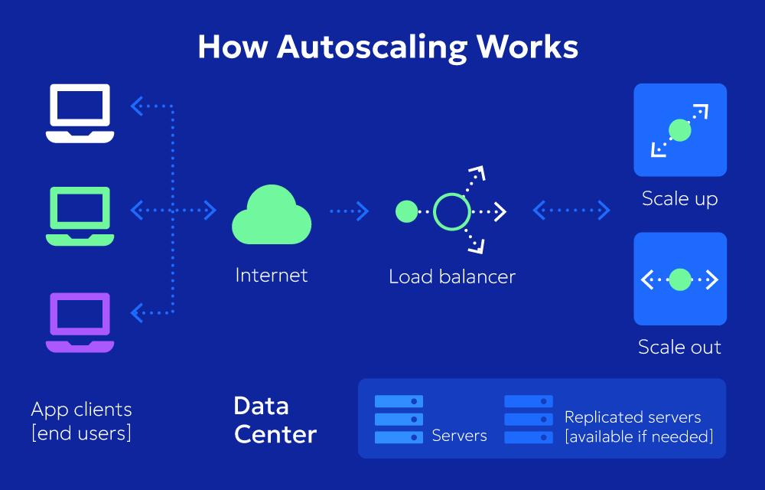
- Normal Period: A small number of application servers handle regular student requests.
- Demand Increase: During admissions and examinations, the number of users increases significantly.
- Monitoring: The cloud monitoring system checks CPU utilization, memory usage, and incoming requests.
- Scale Out: Additional virtual machines or containers are automatically created when demand exceeds predefined thresholds.
- Load Distribution: The load balancer distributes requests across the available servers.
- Scale In: After the peak period, unnecessary instances are removed to reduce costs.
Example:
Period | Server Requirement | Action
Normal Academic Days | 2 application instances | Maintain normal capacity.
Admission Period | 6 application instances | Increase resources to handle registration traffic.
Examination Period | 8 application instances | Provide additional capacity for online examinations.
After Examinations | 2 application instances | Reduce resources and minimize cost.
Note: The instance counts are illustrative design assumptions, not measured university traffic figures.
6. Security and Availability Measures
Security and availability are important because the university handles sensitive student, faculty, financial, and examination information.
Security / Availability Measure | Implementation | Benefit
Access Control | Role-Based Access Control (RBAC) for students, faculty, and administrators. | Prevents unauthorized access to information.
Authentication | Multi-Factor Authentication (MFA). | Provides additional login protection.
Data Encryption | HTTPS/TLS for data transmission and encryption at rest. | Protects sensitive information.
Regular Backup | Automatic daily database and file backups. | Helps recover lost information.
Multi-Zone Deployment | Deploy application servers across two or more availability zones. | Reduces downtime if one zone fails.
Disaster Recovery | Replicate critical databases and backups to a secondary region. | Supports recovery after major failures.
Monitoring | Monitor CPU, memory, network traffic, and application health. | Detects failures and performance problems.
Proposed Security Architecture
- Students can access only their own academic information.
- Faculty can manage attendance and authorized academic records.
- Administrators can manage users, roles, and permissions.
- Examination data must have restricted access.
- Database credentials and API keys must be stored securely.
- Regular security updates and vulnerability assessments must be performed.
7. Overall Advantages of the Proposed Architecture
- Cost Efficiency: Reduces the need for maintaining multiple physical servers.
- Scalability: Handles increasing student traffic during admissions and examinations.
- High Availability: Multi-zone deployment reduces service interruptions.
- Security: Encryption and role-based access protect university information.
- Flexibility: Combines IaaS, PaaS, and SaaS according to application requirements.
- Disaster Recovery: Maintains backup copies and supports application restoration.
8. Conclusion
The proposed hybrid cloud architecture combines server virtualization, web services, and cloud service models to create an efficient university IT infrastructure. Virtual machines and containers improve resource utilization, while APIs connect different university applications. IaaS, PaaS, and SaaS provide flexible infrastructure, application development platforms, and ready-to-use software services. Auto-scaling supports admission and examination traffic, while encryption, access control, multi-zone deployment, and disaster recovery improve security and availability.
Therefore, the proposed architecture provides a secure, scalable, cost-effective, and reliable cloud solution for the university.
Important points for your 5-mark assignment:
- Labelled cloud architecture diagram.
- Hybrid cloud deployment model.
- IaaS, PaaS, and SaaS selection for each component.
- Auto-scaling during admission and examination peaks.
- Security measures: RBAC, MFA, encryption, and monitoring.
- Availability measures: backup, replication, multi-zone deployment, and DR region.
TASK 9 – Hands-on Implementation and Documentation (4 Marks)
1. Introduction
The objective of this task is to implement a small Proof of Concept (PoC) based on the proposed university cloud architecture.
For this implementation, a simple University Student Result Management System will be developed and deployed using Docker. It will provide a REST API to retrieve student examination results.
The implementation demonstrates:
- Virtualization using Docker containers.
- Hosting a university application.
- REST API development and testing.
- Cloud service integration using a hosted platform or database.
- Testing through a browser, Postman, or curl.
2. Proposed Implementation
Recommended PoC: Docker + REST API
Application: University Student Result Management System
Tools required:
Tool | Purpose
Visual Studio Code | Writing and editing application code.
Docker Desktop | Creating and running containers.
Python | Developing the REST API.
FastAPI | Creating REST web services.
Browser / Postman | Testing the web service.
Docker Hub (optional) | Storing the Docker image.
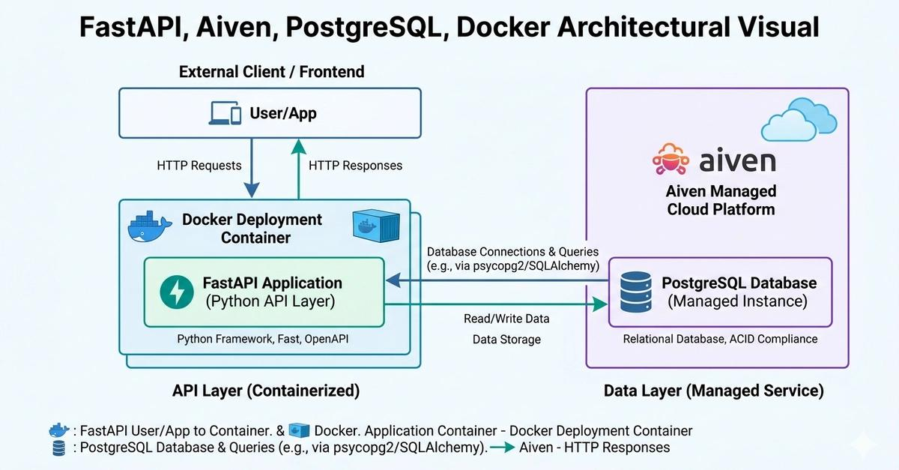
Expected Output
The application should provide the following student information:
- Registration Number
- Student Name
- Department
- Semester
- Subject
- Grade
- Result Status
For example, when a user requests student results using the registration number, the REST API returns the corresponding student information in JSON format.
3. Step-by-Step Implementation
Step 1: Install the Required Software
Download and install the following tools:
- Docker Desktop – for running containers.
- Visual Studio Code – for writing code.
- Python – for application development.
After installation, open Command Prompt and check the versions.
docker --version
python --version
Screenshot 1: Capture the Command Prompt showing successful Docker and Python version checks.
Step 2: Create the Project Folder
Create a folder named:
University_Cloud_POC
Open this folder in Visual Studio Code.
Create the following project structure:
University_Cloud_POC/
│
├── main.py
├── requirements.txt
├── Dockerfile
└── README.md
Step 3: Develop the REST API
Open main.py and enter the following code.
from fastapi import FastAPI, HTTPExceptionapp = FastAPI( title="University Student Result API", description="Cloud-based university result management service")students = { "U2025001": { "student_name": "Aarav", "department": "Computer Science", "semester": 5, "subject": "Cloud Computing", "grade": "A", "result": "PASS" }, "U2025002": { "student_name": "Priya", "department": "Information Technology", "semester": 5, "subject": "Cloud Computing", "grade": "A+", "result": "PASS" }}@app.get("/")def home(): return { "message": "University Cloud API is running", "status": "SUCCESS" }@app.get("/students/{reg_no}/results")def get_result(reg_no: str):
The above program creates two REST API endpoints:
- / – Checks whether the university API is running.
- /students/{reg_no}/results – Retrieves student examination results using the registration number.
Step 4: Create the Requirements File
Open requirements.txt and add:

fastapi
uvicorn
This file contains the Python packages required to run the application.
Step 5: Create the Dockerfile
Open Dockerfile and add:

FROM python:3.12-slim

WORKDIR /app

COPY requirements.txt .

RUN pip install --no-cache-dir -r requirements.txt

COPY main.py .

EXPOSE 8000

CMD ["uvicorn", "main:app", "--host", "0.0.0.0", "--port", "8000"]
Explanation:
- FROM selects the Python base image.
- WORKDIR creates the application working directory.
- COPY copies project files into the container.
- RUN installs the required Python packages.
- EXPOSE documents the application port.
- CMD starts the REST API server.
Step 6: Build the Docker Image
Open the VS Code terminal inside the project folder.
Execute:
docker build -t university-result-api .
This command creates a Docker image containing the application and its dependencies.
To check the image:
docker images
Screenshot 2: Capture the successful Docker image build and the university-result-api image in the image list.
Step 7: Run the Docker Container
Execute:
docker run -d -p 8000:8000 --name university-api university-result-api
To check whether the container is running:
docker ps
If the container is running, the REST API is available at:
http://localhost:8000
Screenshot 3: Capture Docker Desktop or the terminal showing the running university-api container.
4. Deploy a PaaS Component
For the cloud deployment component, use Render to host the FastAPI application as a web service.
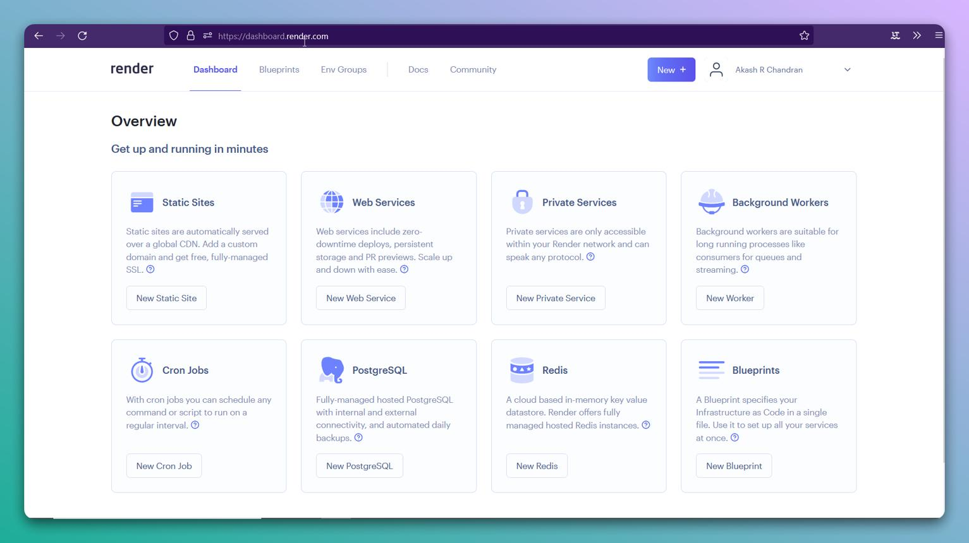
Deployment procedure:
- Create a GitHub account if you do not already have one.
- Create a new repository named University-Cloud-POC.
- Upload main.py, requirements.txt, and Dockerfile.
- Open Render official website.
- Sign in and select the option to create a new Web Service.
- Connect your GitHub repository.
- Select Docker as the deployment environment.
- Select the available plan and deploy the application.
- Wait for the deployment process to complete.
- Copy the generated application URL.
Screenshot 4: Capture the connected GitHub repository and Render deployment configuration.
Screenshot 5: Capture the successful deployment status and generated service URL. Free-plan availability and limits may vary.
Note: The Docker container can be tested locally first. For the cloud deployment, Render builds and runs the Docker image on its managed infrastructure. This demonstrates both containerization and a PaaS hosting model.
Important Dockerfile Update for Cloud Deployment
Before uploading the project to GitHub, replace the last line of the Dockerfile with:
CMD ["sh", "-c", "uvicorn main:app --host 0.0.0.0 --port ${PORT:-8000}"]
This allows the application to use the port assigned by the cloud hosting platform while retaining port 8000 for local testing.
5. Test the Web Service
After running the container, open Google Chrome and enter the following URLs.
Test 1: Check API Status
URL:
http://localhost:8000/
Expected Output:
{
"message": "University Cloud API is running",
"status": "SUCCESS"
}
Test 2: Retrieve Student Results
URL:
http://localhost:8000/students/U2025001/results
Expected Output:
{
"registration_number": "U2025001",
"result_details": {
"student_name": "Aarav",
"department": "Computer Science",
"semester": 5,
"subject": "Cloud Computing",
"grade": "A",
"result": "PASS"
}
}
Test 3: Test Invalid Registration Number
URL:
http://localhost:8000/students/U9999999/results
Expected Output:
{
"detail": "Student not found"
}
Test 4: Interactive API Testing
FastAPI automatically provides interactive API documentation.

Open:
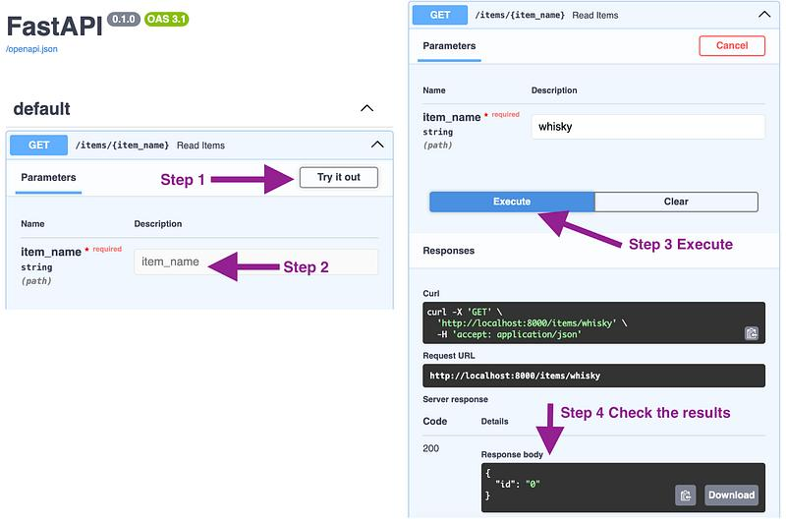Click the GET endpoint, select Try it out, enter the registration number, and click Execute.
Screenshot 6: Capture the Swagger UI showing the successful API response.
For cloud testing, replace localhost:8000 with your deployed Render URL.
6. Configuration and Testing Summary
Test | Input | Expected Result | Status
API Status | / | API running successfully | To be tested
Student Result | /students/U2025001/results | Student result displayed | To be tested
Invalid Student | /students/U9999999/results | 404 Student not found | To be tested
API Documentation | /docs | Interactive API documentation | To be tested
Cloud Deployment | Render service URL | Application accessible online | To be tested
7. Issues Faced and Solutions
The following are common implementation issues and their solutions. Include only the issues you actually encounter in your report.
Issue | Possible Reason | Solution
Docker command not recognized | Docker is not installed or running. | Install and start Docker Desktop.
Port already in use | Another application is using port 8000. | Use another available host port, such as 8001:8000.
Module not found | Required Python packages are missing. | Install packages using requirements.txt.
Container exits immediately | Application startup error. | Check logs using docker logs university-api.
Cloud deployment fails | Incorrect Dockerfile or build configuration. | Check deployment logs and correct the configuration.
Cloud application unavailable | Incorrect port configuration or deployment failure. | Use the platform-assigned port and check service logs.
8. Screenshots Required for Submission
Capture these screenshots while performing the actual implementation.
Screenshot checklist
Use your own screenshots as implementation evidence.
Evidence collected
0/8
Project folder structure in Visual Studio Code
Python code in main.py
Successful Docker image build
Running Docker container
Render cloud deployment configuration
Successful Render deployment dashboard
Student result JSON response in browser
FastAPI Swagger documentation showing API testing
9. Conclusion
The proof-of-concept implementation demonstrates how a university application can be hosted using Docker containerization and cloud-based PaaS deployment. The Student Result Management API provides student information through REST endpoints and returns results in JSON format. Docker provides application isolation and portability, while Render provides a managed cloud hosting environment. The implementation demonstrates virtualization, web services, cloud deployment, and application testing.
Future Enhancement: The university can connect the application to a managed cloud database, introduce student authentication, and implement role-based access control for improved security.
10. Final Summary
Requirement | Implementation
Create VM or container | Docker container
Host university application | Student Result Management API
Deploy PaaS component | Render Web Service
Web service technology | FastAPI REST API
Data format | JSON
Client testing | Browser and Swagger UI
Documentation | Screenshots, configuration, and testing results
.
TASK 10 – Evaluate and Recommend the Final Cloud Solution (7 Marks)
1. Introduction
Based on the previous tasks, the university requires a cloud solution that can support its Student Information System (SIS), Learning Management System (LMS), library services, examination portal and email system. The solution must reduce infrastructure maintenance, support changing student demand, provide secure access and maintain service availability.
The three possible approaches are:
- On-premise: All applications and servers are maintained within the university.
- IaaS-based: The university rents virtual machines, storage and networking from a cloud provider but manages its operating systems and applications.
- PaaS/SaaS-based: The university uses managed application platforms and ready-to-use cloud software, reducing infrastructure and maintenance work.
2. Comparison of the Three Solutions
Evaluation factor | On-premise | IaaS-based | PaaS/SaaS-based
Cost | High initial CapEx for servers, storage and networking | Lower initial cost; recurring OpEx | Mostly subscription or usage-based OpEx
Scalability | Requires purchasing and installing hardware | Resources can be increased or decreased when required | Managed platforms and applications can scale with demand, subject to service limits
Availability | University must maintain backup servers and disaster recovery | Cloud infrastructure supports multi-zone deployment and backup configurations | Providers manage much of the underlying availability, depending on the service agreement
Security | University manages physical and technical security | Shared responsibility between provider and university | Provider manages more infrastructure; university still manages accounts, access and data settings
Maintenance effort | High; university manages hardware, software and updates | Medium; provider manages physical infrastructure, while university manages VMs and applications | Low to medium; provider manages most platform or application maintenance
Control | Highest control | High control over operating systems and applications | Less control over underlying infrastructure
Evaluation: On-premise offers greater direct control but requires high investment and maintenance. IaaS provides flexibility while retaining control over applications. PaaS/SaaS reduces operational effort and is suitable for standard university services.
3. Estimated Three-Year Cost Comparison
The following is an illustrative estimate in Indian rupees, not a quotation from a cloud provider. It assumes a medium-sized university with moderate application usage, existing campus internet connectivity and a requirement for backup and security.
Cost assumptions
- On-premise: Server and storage purchase, networking upgrades, maintenance, electricity, cooling, backup and IT support.
- IaaS: Cloud virtual machines, storage, networking and backup, plus university staff to manage operating systems and applications.
- PaaS/SaaS: Managed application platforms, database services and subscriptions, with a smaller university administration effort.
- All figures are assumed planning amounts; taxes, major customisation and unexpected growth are excluded.
Cost component | On-premise | IaaS-based | PaaS/SaaS-based
Initial setup / migration | ₹18,00,000 | ₹3,00,000 | ₹2,00,000
Monthly infrastructure / service cost | ₹0 | ₹90,000 | ₹75,000
Annual maintenance / IT administration | ₹6,00,000 | ₹2,40,000 | ₹1,20,000
Three-year recurring service cost | ₹0 | ₹32,40,000 | ₹27,00,000
Three-year maintenance / administration | ₹18,00,000 | ₹7,20,000 | ₹3,60,000
Estimated three-year total | ₹36,00,000 | ₹42,60,000 | ₹32,60,000
Calculation
- On-premise: ₹18,00,000 + (₹6,00,000 × 3) = ₹36,00,000
- IaaS: ₹3,00,000 + (₹90,000 × 36) + (₹2,40,000 × 3) = ₹42,60,000
- PaaS/SaaS: ₹2,00,000 + (₹75,000 × 36) + (₹1,20,000 × 3) = ₹32,60,000
Estimated three-year cost
Illustrative planning estimates in Indian rupees; lower is less expensive.
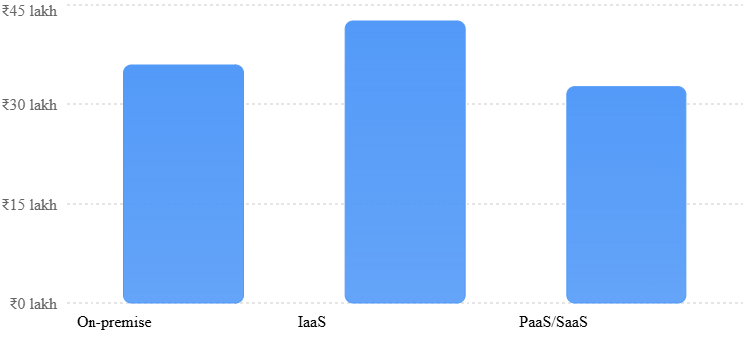
Result: Under these assumptions, PaaS/SaaS has the lowest three-year cost. IaaS costs more in this example because the university continues to pay for cloud infrastructure and internal administration. Actual costs depend on the provider, region, storage, data transfer, licensing and usage. Cloud pricing calculators should be used before procurement.
AWS Documentation+2
4. Main Risks and Mitigation Strategies
Risk | Possible impact | Mitigation
Vendor lock-in | Difficulty moving applications and data to another provider | Use open standards, REST APIs, containers and portable data formats; maintain data export and exit plans
Data privacy | Exposure of student records, examination data or financial information | Encrypt data, apply role-based access control (RBAC), enable MFA, maintain audit logs and follow applicable data-protection requirements
Downtime | Students and staff may lose access to important services | Use backups, multi-zone deployment, disaster recovery, uptime monitoring and documented recovery procedures
Skills gap | IT staff may struggle to manage cloud services | Provide staff training, practical workshops, documentation and support from qualified cloud specialists
Unexpected cost growth | Uncontrolled usage may increase monthly bills | Set budgets, billing alerts, resource limits and regular cost reviews
Cloud security is a shared responsibility: the provider protects the underlying cloud infrastructure, while the university remains responsible for areas such as user access, application configuration and its data. The exact division depends on the service selected.
Amazon Web Services (AWS)+1
5. Final Cloud Solution Recommendation
Recommended solution: Hybrid Cloud using a combination of IaaS, PaaS and SaaS.
A fully on-premise solution is not recommended because it requires high initial investment, hardware maintenance and manual capacity upgrades. A completely IaaS-based solution would improve scalability but still require the university to manage operating systems, applications and much of the maintenance.
A hybrid approach provides a better balance between cost, flexibility, security and control.
University application | Recommended service model | Justification
Student Information System (SIS) | IaaS | Provides control over the existing application and its configuration
Learning Management System (LMS) | PaaS | Supports application development, deployment and scaling with less infrastructure management
Digital Library | SaaS | A standard library service can be managed by a specialised provider
Examination Portal | IaaS initially | Retains application control while allowing additional resources during examination periods
University Email | SaaS | Reduces email-server maintenance and provides a managed service
The recommendation follows the earlier architecture: use a hybrid deployment, REST/SOAP APIs for integration, virtualisation or containers for application deployment, and backup/disaster-recovery arrangements for important services.
6. Migration Roadmap
The university should migrate gradually rather than transferring every application at once.
- Phase 1 – Assessment and preparation
Identify existing applications, data volumes, dependencies, security requirements and expected workloads. Select a cloud provider after comparing cost, service availability, data-location requirements and support.
- Phase 2 – Migrate the Digital Library and Email
Move the library catalogue and email services first. These are suitable starting points because managed services can reduce maintenance effort and help the university gain experience with cloud operations.
- Phase 3 – Migrate the LMS to PaaS
Move the Learning Management System to a managed platform. Test access for students and faculty, application performance, backups and integration with other university systems.
- Phase 4 – Migrate the SIS to IaaS
Move the Student Information System after testing data migration, authentication, role-based permissions and database connectivity. Keep a verified backup before switching users to the cloud system.
- Phase 5 – Migrate the Examination Portal
Migrate the examination portal only after performance, security and recovery tests. Conduct load testing to confirm that it can handle large numbers of users during examination periods.
- Phase 6 – Monitoring and optimisation
Monitor availability, security alerts, application performance and monthly spending. Maintain disaster recovery arrangements and review the cloud architecture regularly.
7. Conclusion
After comparing the three approaches, the Hybrid Cloud model combining IaaS, PaaS and SaaS is the most suitable solution for the university. It reduces the need for expensive physical infrastructure, provides scalability during admissions and examinations, and reduces maintenance through managed services.
The estimated three-year cost of the PaaS/SaaS option is ₹32.6 lakh, compared with ₹36 lakh for on-premise and ₹42.6 lakh for IaaS under the stated assumptions. The recommended hybrid solution can use PaaS/SaaS for suitable standard applications and IaaS where greater application control is required.
A phased migration, supported by encryption, access control, backups, disaster recovery and staff training, will help the university move to the cloud with lower operational risk.
References
- Amazon Web Services, AWS Pricing Calculator Documentation. AWS Pricing Calculator.
- Amazon Web Services, Shared Responsibility Model. AWS Shared Responsibility Model.
- Microsoft, Estimate Costs with the Azure Pricing Calculator. Azure Pricing Calculator Documentation.
- Google Cloud, Estimate Your Monthly Costs. Google Cloud Cost Estimation.
Note: The cost figures are academic estimates based on stated assumptions, not verified provider quotations. A final procurement decision should use actual application requirements and provider-specific pricing calculators.

TASK 11 – Re-evaluate and Adapt the Design (8 Marks)
1. Introduction
The university has introduced new requirements that significantly increase the workload and complexity of the original cloud architecture.
The changed requirements are:
- Launch a mobile application for students.
- Provide student-record and fee-payment services to 40 affiliated colleges.
- Support an expected load of 10 times the current peak workload.
- Maintain 99.9% service availability.
- Operate within a limited budget.
The original hybrid cloud architecture must therefore be evaluated to determine whether it can satisfy these requirements.

2. Re-evaluation of the Original Design
The original design used a hybrid cloud model combining IaaS, PaaS and SaaS. It supported the university's SIS, LMS, digital library, examination portal and email services.
However, the new requirements introduce more users, external college

